AMRITA VISHWA VIDYAPEETHAM CHENNAI CAMPUS

Second Year. B.Tech (Computer Science and Engineering)

Problem Solving using ‘C’ programming

Work Book

(From Academic year 2025-26 ODD)

Name: KANIPAKAM POOJITHA College Name: Amrita Vishwa Vidyapeetham, Chennai Roll No.: CH.SC.U4CSE24022 Department: CSE

Academic Year: 2025-26

Preface to the First Edition

The new syllabus for First Year B.Tech Computer Science is implemented from the academic year 2022.

It is absolutely necessary and essential that all the Computer Science practicals be conducted on Open Source Operating System like Linux or windows. All the practical’s related to C needs to be conducted using GCC compiler.

.

It is mandatory to carry the completed and duly signed lab Activity sheets for the practical examination.

Lab Incharge: Dr J.Umamageswaran

Introduction

1. About the work book

This workbook is intended to be used by First Year B.Tech. (Computer Science) students for the Computer Science laboratory courses in their curriculum. In Computer Science, hands-on laboratory experience is critical to the understanding of theoretical concepts studied in the theory courses. This workbook provides the requisite background material as well as numerous computing problems covering all difficulty levels.

The objectives of this book are

1. Defining clearly the scope of the course
2. Bringing uniformity in the way the course is conducted across different colleges
3. Continuous assessment of the course
4. Bring in variation and variety in the experiments carried out by different students in a batch
5. Providing ready reference for students while working in the lab
6. Catering to the need of slow paced as well as fast paced learners
7. **How to use this work book?**

This workbook is mandatory for the completion of the laboratory course. It is a measure of the performance of the student in the laboratory for the entire duration of the course.

* 1. **Instructions to the students**

Please read the following instructions carefully and follow them

1. Carry this book every time you come to the lab for computer science practical’s
2. You should prepare yourself beforehand for the Exercise by reading the material mentioned under.
3. If the self-activity exercise or assessment work contains any blanks such as , get them filled by your instructor.
4. Instructor will specify which problems you are to solve by ticking box
5. You will be assessed for each exercise on a scale of 5
   1. Not done 0 ii) Incomplete 1
6. Late Complete 2 iv) Needs improvement 3

v) Complete 4 vi) Well Done 5

**2.2. Instruction to the Instructors**

1. Explain the assignment and related concepts in around ten minutes using white board if required or by demonstrating the software
2. Fill in the blanks with different values for each student
3. Choose appropriate problems to be solved by student by ticking box
4. Make sure that students follow the instruction as given above
5. After a student completes a specific set, the instructor has to verify the outputs and sign in the provided space after the activity.
6. You should evaluate each assignment carried out by a student on a scale of 5 as specified above by ticking appropriate box.
7. The value should also be entered on assignment completion page of the respective Lab course

**2.3. Instructions to the Lab administrator**

You have to ensure appropriate hardware and software is made available to each student.

The operating system and software requirements on server side and also client side are as given below

1. Server Side (Operating System)
   1. * Fedora Core Linux *
   2. Servers Side (software’s to be installed)

In Linux – C, C++, awk, shell, perl, postgresql/Mysql

1. Client Side ( Operating System )

* Red Hat Linux and Fedora Core * Client Side ( software’s to be installed )

In Linux – C, C++, awk, shell, perl, postgresql/mysql

Information about installation and configuring of the server and client are provided in appendix A

**Activity Completion Sheet**

|  |  |  |
| --- | --- | --- |
| **Problem Solving and C programming** | | |
| **Sr.No** | **Assignment Name** | **Marks** |
| 1 | Problem Solving using Pseudo code and Flowchart, Simple programs, Understanding errors and error handling. |  |
| 2 | Decision Making Control Structures. |  |
| 3 | Loop Control Structures |  |
| 4 | Functions (User Defined functions, Library functions and Recursion). |  |
| 5 | Arrays (1-D and 2-D) |  |
| 6 | Strings |  |
| 7 | Pointers |  |

*C E R T I F I C A T E*

This is to certify that, Mr./Miss. Roll No. of

I year B.Tech. (Computer Science and Engineering) has successfully completed out of practical’s

satisfactorily during the academic year 20 - 20 .

Practical In-charge Chairperson

Problem Solving using ‘C’ programming

You should read following topics before starting this exercise

## 1. UNIX and LINUX operating system About UNIX and LINUX

The success story of UNIX starts with the failure of the MULTICS project. The project failed and the

powerful GE-645 machine was withdrawn by GE. Two scientists at Bell Labs, Ken Thompson and Dennis Ritchie, who were part of the MULTICS team, continued to work and succeeded and named their Operating system UNIX, a pun on MULTICS.

The machine available at Bell Labs was a DEC PDP-7 with only 64 k memory while the Operating system they were developing was meant for a larger machine. The problematic situation was handled with an innovative solution. They developed most part of the software in a higher-level language, C, which helped them in porting their Operating system from one hardware to another.

With the growing popularity of UNIX, it was available on a variety of machines, from personal computers to mainframes. The most popular amongst them was UNIX System V from AT&T.

Each big player in the market came up with their own versions of UNIX. IBM had its own version of UNIX called AIX, which was used on high-end servers. Sun’s version of UNIX called Solaris was used on Sun workstations. Novell marketed UnixWare along with Netware, its Network operating system. LINUX is a version of UNIX, which though it resembles UNIX in looks and feels but differs from other versions in the way it was developed and distributed. In contrast to large proprietary UNIX versions, Linux was developed by Linus Torvalds, a Finnish student. He made the source code available and invited partners via the internet in his development effort. He got professional help from all quarters and Linux evolved rapidly. It was made freely available for everyone to use. Linux that was initially meant for Personal computers is now available for a variety of hardware platforms, from mainframes to handheld computers

Linux supports multiple users. Every user needs to have an account in order to use the system. One of the users called system administrator (root) is given the charge of creating user accounts and managing the system normally works on the “#” prompt.

You will be given a username and password, using which you can login into Linux operating system. For computer users, the operating system provides a user-command interface that is easy to use, usually called the Shell. The user can type commands at the shell prompt and get the services of the operating system. Linux operating system shell has the “$” prompt.

You can open a system terminal that gives you a $ prompt where you can type in various shell commands.

LINUX system will usually offer a variety of shell types:

* sh or Bourne Shell: the original shell still used on UNIX systems and in UNIX-related environments. It is available on every Linux system for compatibility with UNIX programs.
* bash or Bourne Again shell: the standard GNU shell, is the standard shell for common users on Linux and is a superset of the Bourne shell.
* csh or C shell: the syntax of this shell resembles that of the C programming language.
* tcsh or Turbo C shell: a superset of the common C shell, enhancing user-friendliness and speed.
* ksh or the Korn shell: A superset of the Bourne shell

# Activity Sheet 1 Date:

Problem Solving using Pseudo code and Flowchart, Simple programs, understanding errors and error handling.

**Objective-**To demonstrate the use of data types, simple operators and expressions

# Reading-

You should read following topics before starting this exercise

1. Problem solving steps- writing algorithms and flowcharts
2. Different basic data types in C and rules of declaring variables in C
3. Different operators and operator symbols in C
4. How to construct expressions in C, operator precedence

## Program solving using Computers

The steps in solving a problem using computers are shown below

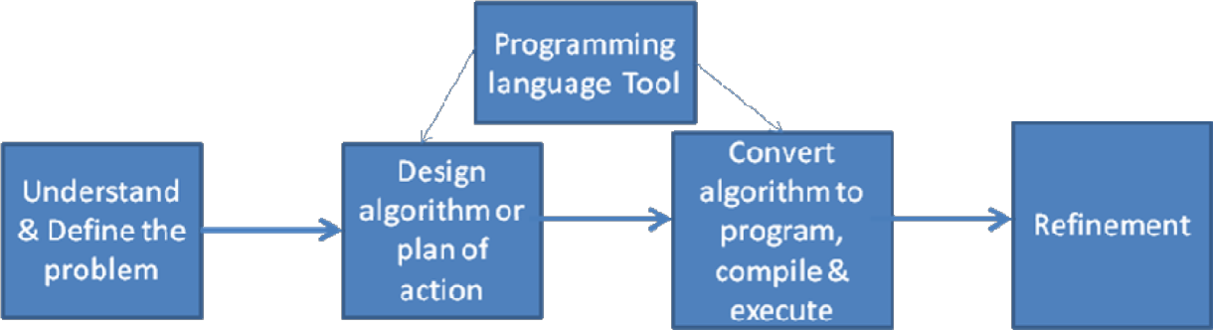

**Pseudo Language conventions**

* 1. Appropriate names should be given to variables – the algorithm itself is given a name

Algorithm FindingMaximum

* 1. Organized sequence of data values is given a name and each data value is indicated by giving the index in brackets

Values[position]

* 1. Expressions containing Arithmetic operators +, -, * , / relational operators <, ≤ , >, ≥,

≠, = and logical and, or , not can be used

Example: length * breadth, previous < next

* 1. Assignment statement variable = expression is used to assign data values to variables
  2. Conditional constructs for making decisions if condition then statements

Statements are to be carried out only if condition is true if condition then statements1 else statements2

Statements1 are to be carried out only if condition is true and statements2 are to be carried out if condition is false

* 1. Loops
     1. while condition do statements

Statements are to be repeated while condition is true

* + 1. for variable = value1 to value2 do statements

Statements are to be repeated moving from value1 to value2, with an increment one step.

* + 1. for variable = value1 downto value2 do { statements }

Statements are to be repeated moving from value1 down to value2, with a decrement one step.

* + 1. repeat { statements } until condition

Statements are to be repeated until condition is true

* 1. Input /output statements
     1. read value For taking value as input for the algorithm
     2. write value For printing value as output of the algorithm
  2. Algorithm name( value1 , valu2) – taking input for the algorithm
  3. return value1 , value2 – for giving output of the algorithm

**Examples:**

**Problem Statement**: Accept radius and calculate area and circumference of a circle Algorithm AreaCircumference

Begin

area End

Input radius pi=3.142 area = piXradiusXradius

circum= 2XpiXradius Output Output circum

**Problem Statement**: Check if a number is even Algorithm Even

Begin Input m if m mod 2 = 0 then

output “m is even”

End

**Problem Statement:** Find maximum of two numbers Algorithm Maximum

Begin

Input m Input n if m > n then output m

else output n

End

**Problem Statement**: Give a discount of 15 % when purchase amount exceeds 5000, otherwise give a discount of 10%

Algorithm Discount Input amount

if amount exceeds 5000 then compute discount as 25 times amount divided by 100

else compute discount as 15 times amount divided by 100 Subtract discount from amount

Output amount End

**Problem Statement:** Given a set of 100 values representing marks of students, count the total students that have passed. (A score of 40 is required for passing.)

Algorithm PassCount1 Begin

count = 0

n = 1

While n <= 100 do

Input marks

If marks >= 40 then

increment count by 1 n = n+1

Output count

End

The same can be done using another loop construct as shown below: Algorithm PassCount1

Begin

count = 0

for n = 1 to 100 do

Input marks

If marks >= 40 then increment count by 1 Output count

End

**Problem Statement:** Accept characters till a * is entered from the keyboard and count the number of characters entered.

Algorithm CharacterCount Begin

count = 0 Input char

while char ≠ * do count = count + 1

End

Output count

Input char

**Problem Statement**: Accept a number and calculate the sum of its digits.

Algorithm SumDigits Begin

Input num sum=0 repeat

digit = num mod 10 sum=sum+digit

num = num/10 until num>0 Output sum

End

**FLOWCHART SYMBOLS**

|  |  |
| --- | --- |
| Start Statement | start |
| Input Statement |  |
| Statement or procedure |  |
| Decision, choice or Selection |  |
| Connectors |  |

|  |  |
| --- | --- |
| Control flow |  |

Basic control structures in an algorithm: Sequence, Selection and Iteration are shown below

|  |  |
| --- | --- |
| .Sequence | false true  Selection |
| true  false  Top tested Iteration | true  false  Bottom tested Iteration |

1. **Data type Table**

|  |  |  |  |  |  |
| --- | --- | --- | --- | --- | --- |
| Data | Data Format | C Data  Type | C Variable  declaration | Input Statement | Output statement |
| quantity month creditcard number | Numeric | int Short int long int | int quantity; short month;  long ccno; | scanf(“%d”,&quantity); scanf(“%d”,&month);  scanf(“%ld”, &ccno); | printf(“The quantity is %d”, quantity); printf(“Credit card number is %ld, ccno); |
| price π | real | float double | float price; const double pi=3.141593  ; | scanf(“%f”,&price); | printf(“The price is %5.2f”, price); |
| grade | character |  | char grade; | scanf(“%c”,&grade) | printf(“The grade is %c”,grade); |

## Expression Examples

|  |  |
| --- | --- |
| **Expression** | **C expression** |
| Increment by a 3 | a = a + 3 |
| Decrement b by 1 | b = b-1 or b-- |
| 2 a2 + 5 b/2 | 2*a*a + 5*b/2 |
| 7/13(x-5) | (float)7/13*(x-5) |
| 5% of 56 | (float)5/100*56 |
| n is between 12 to 70 | n>=12 && n<=70 |
| πr2h | Pi*r*r*h |
| n is not divisible by 7 | n % 7 != 0 |
| n is even | n%2== 0 |
| ch is an alphabet | ch>=’A’ && ch<=’Z’ || ch>=’a’ && ch<=’z’ |

|  |  |  |
| --- | --- | --- |
| **Step 1: Writing the**  **Pseudocode** | **Step 2: Draw the**  **flowchart** | **Step 3: Write the Program** |
| Algorithm SimpleInterest  Begin  Input amount, rate, years  si =amountXyearsXrate / 100 Output si  End | start  Read ,principal sum, rate and no of years  Compute Simple interest  Print Simple Interest  stop | #include <stdio.h> void main( )  {  /* variable declarations */  float amount, rateOfInterest, simpleInterest; int noOfYears;  /* prompting and accepting input */ printf(“Give the Principal Sum”); scanf(“%f”,&amount);  printf(“Give the Rate of Interest”); scanf(“%f”,&rateOfInterest); printf(“Give the Number of years”); scanf(“%d”,&noOfYears);  /* Compute the simple Interest*/ simpleInterest=amount*noOfYears*rateOfInterest / 100  ;  /* Print the result*/  printf(“The simple Interest on amount %7.2f for %d years at the rate %4.2f is %6.2f”, amount, noOfYears, rateOfInterest, simpleInterest);  } |

**Self-Activity**

1. Type the sample program given above. Execute it for the different values as given below and fill the last column from the output given by the program. Follow the following guidelines
   1. At $ prompt type gedit followed by filename. The filename should have .c as extension for example $gedit pnr.c
   2. Type the sample program and save it. Compile the program using cc compiler available in Linux

$cc pnr.c

It will give errors if any or it will give back the $ prompt if there are no errors

A executable file a.out is created by the compiler. The program can be executed by typing name of the file as follow $ ./a.out

Alternatively, the executable file can be given name by using –o option while compiling as follows $cc pnr.c –o pnrexec

$./pnrexec

|  |  |  |  |  |
| --- | --- | --- | --- | --- |
| Sr. No | Principal sum | No of years | Rate of interest | Simple Interest |
| 1 | 2000 | 3 |  |  |
| 2 | 4500 |  | 4.5 |  |
| 3 |  | 6 | 8.3 |  |

**Problem Solving using Pseudo code and Flowchart, Simple programs, understanding errors and error handling.**

***Objective-To demonstrate the use of data types, simple operators and expressions***

**Problem Statement – 1:** Accept radius and calculate area and circumference of a circle

**CODE:**

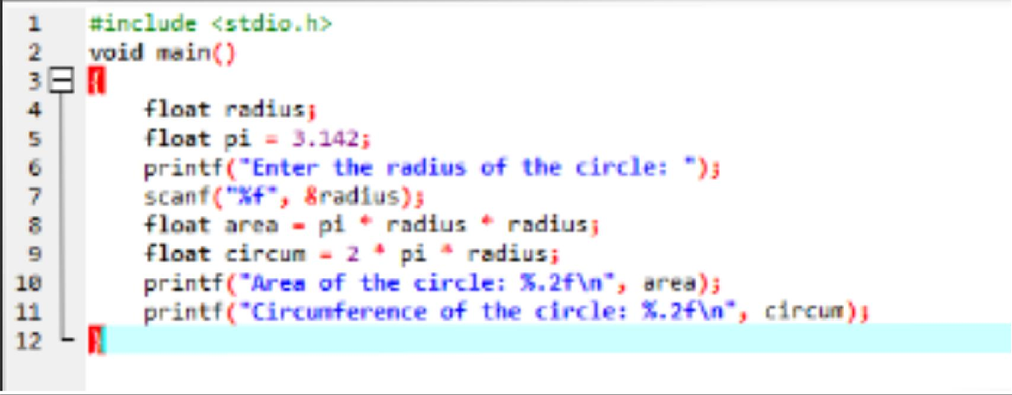

**OUTPUT:**

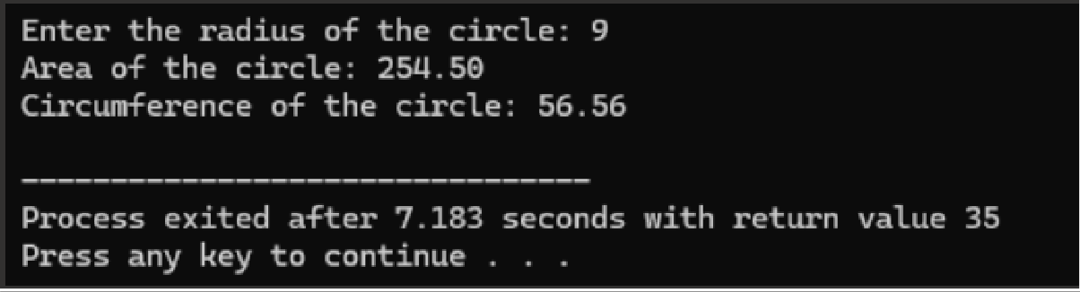

**Problem Statement - 2:** Check if a number is even

**CODE:**

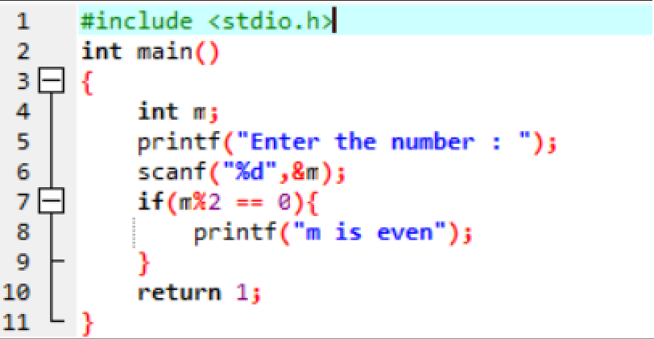

**OUTPUT:**

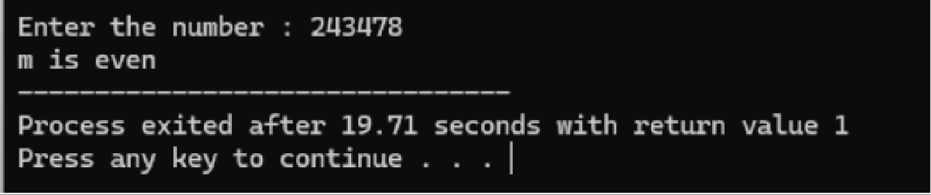

**Problem Statement - 3:** Find maximum of two numbers

**CODE:**

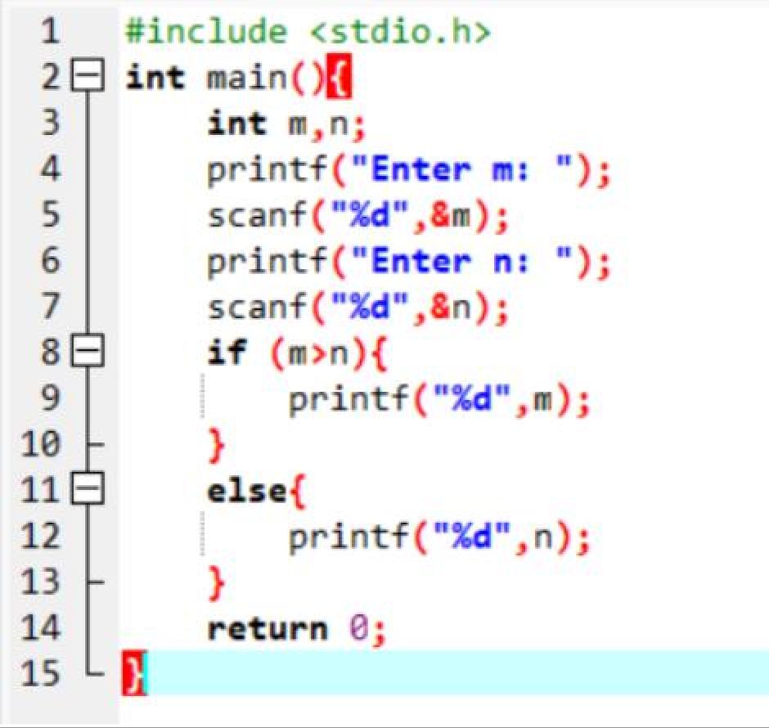

**OUTPUT:**

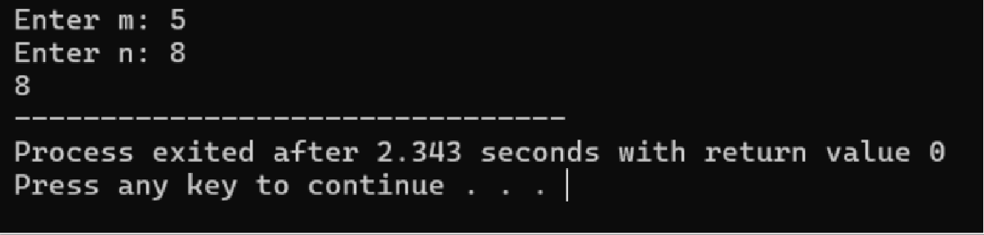

**Problem Statement – 4:** Give a discount of 25 % when purchase amount exceeds 5000, otherwise give a discount of 15%

**CODE:**

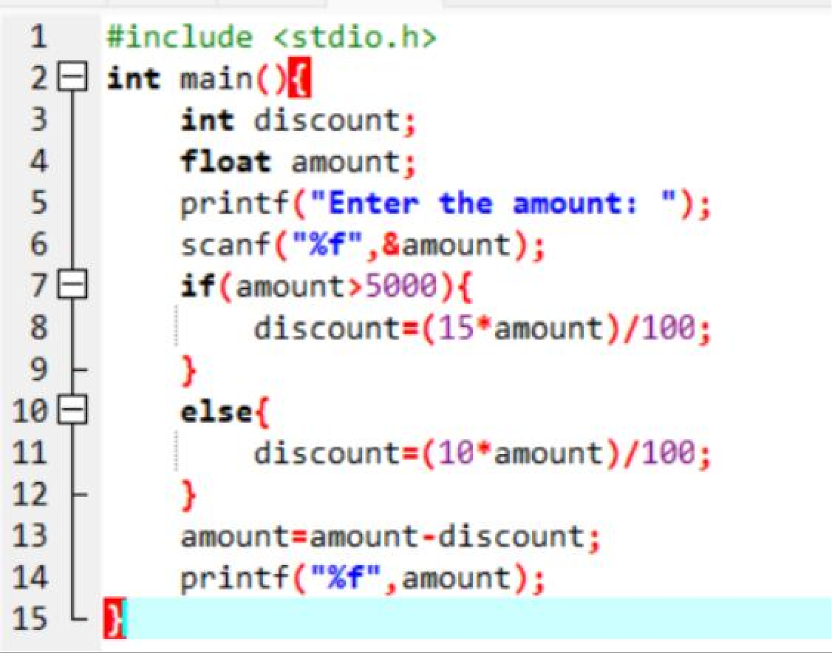

**OUTPUT:**

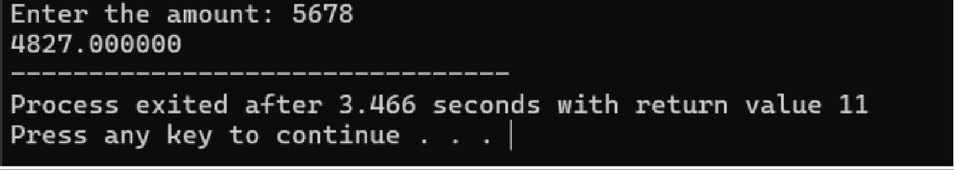

**Problem Statement –** 5**:** Given a set of 5 values representing marks of students, count the total students that have passed. (A score of 40 is required for passing.)

**CODE :**

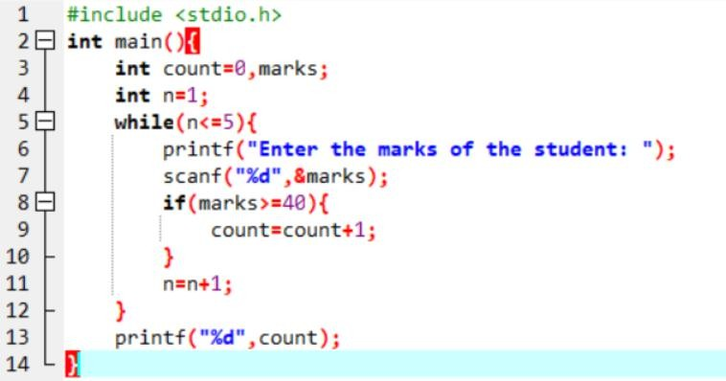

**OUTPUT:**

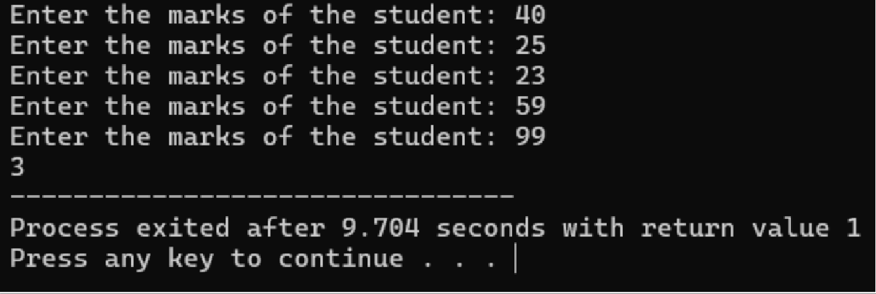

**Problem Statement – 6:** Accept characters till a * is entered from the keyboard and count the number of characters entered

**CODE:**

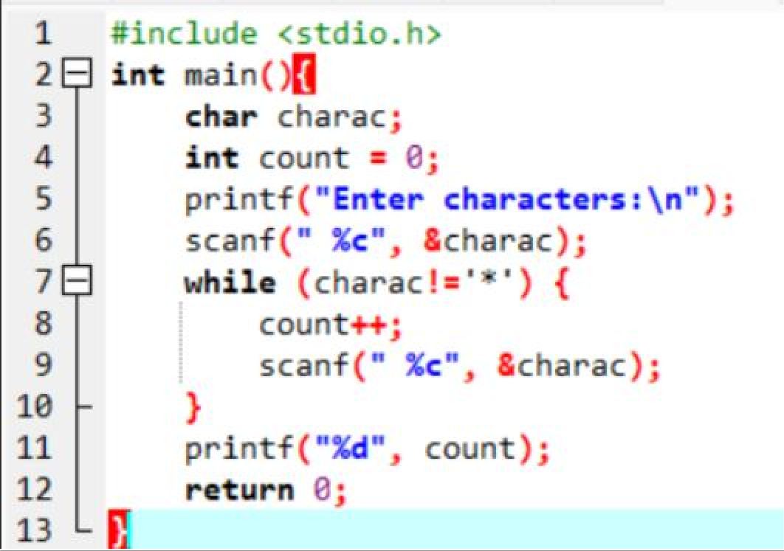

**OUTPUT:**

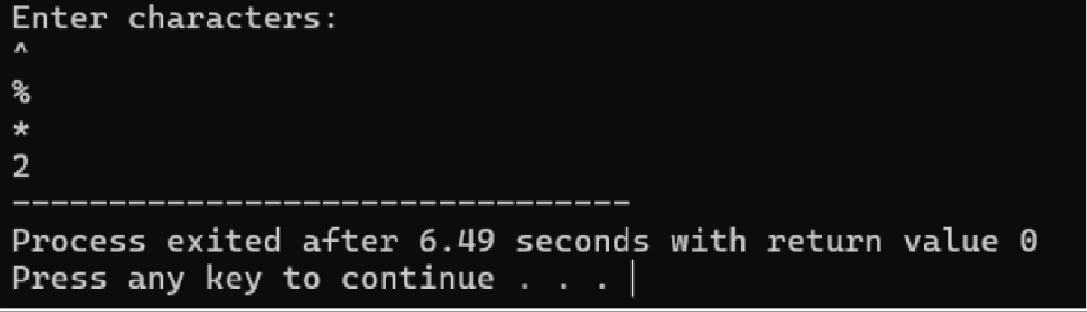

**Problem Statement – 7:** Accept a number and calculate the sum of its digits.

**INPUT:**

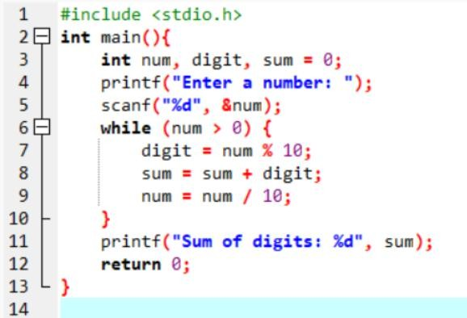

**OUTPUT:**

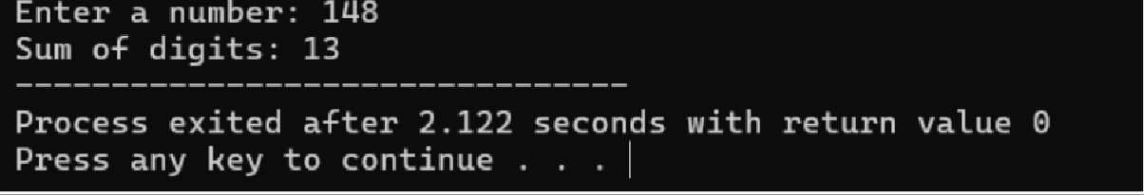

**Q1)**

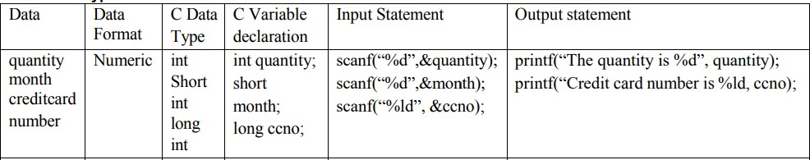

**CODE:**

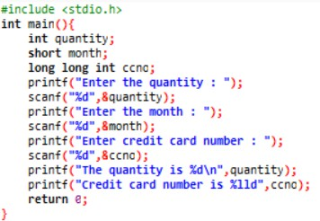

**OUTPUT:**

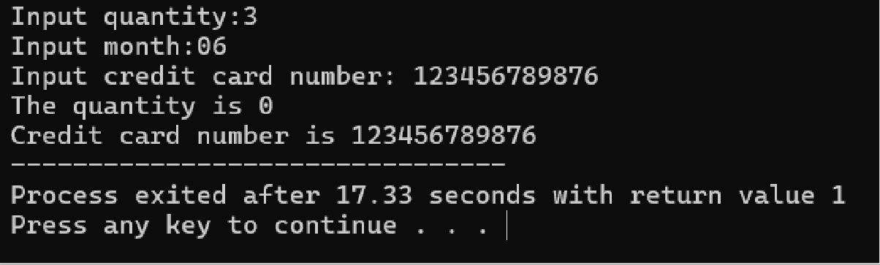

**Q2)**

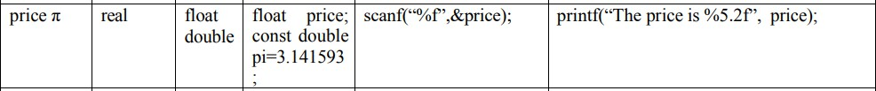

**CODE:**

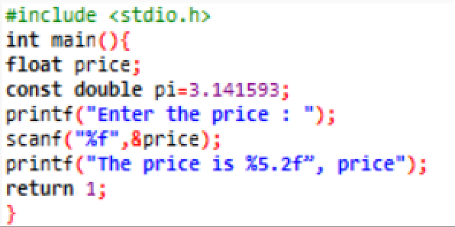

**OUTPUT:**

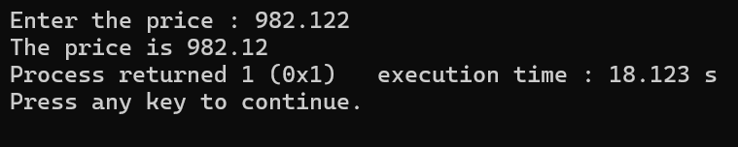

**Q3)**



**CODE:**

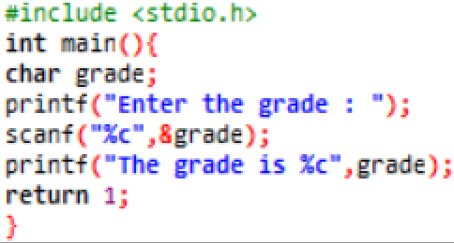

**OUTPUT:**

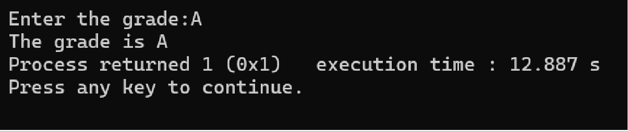

**SELF ACTIVITY:**

|  |  |  |  |  |
| --- | --- | --- | --- | --- |
| **Sr_no** | **Principle**  **amount** | **No of year** | **Rate of Intrest** | **Simple intrest** |
| **1** | **2000** | **3** | **3.4** | **204.00** |
| **2** | **4500** | **2** | **4.5** | **405.00** |
| **3** | **7800** | **6** | **8.3** | **3884.40** |

**CODE:**

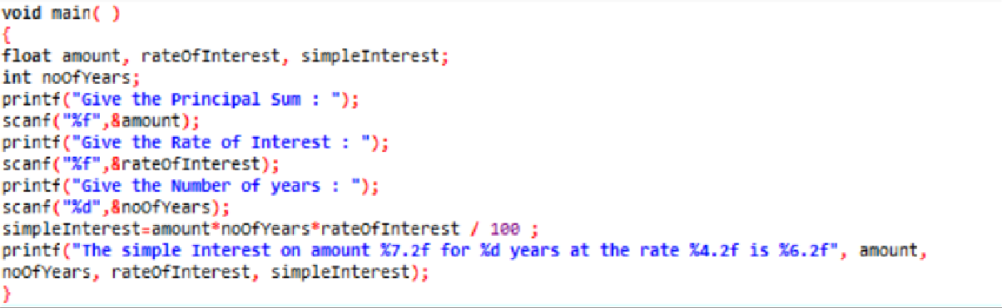

**OUTPUT – 1:**

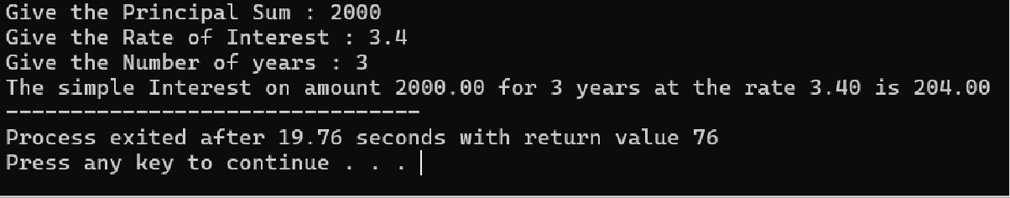

**OUTPUT – 2:**

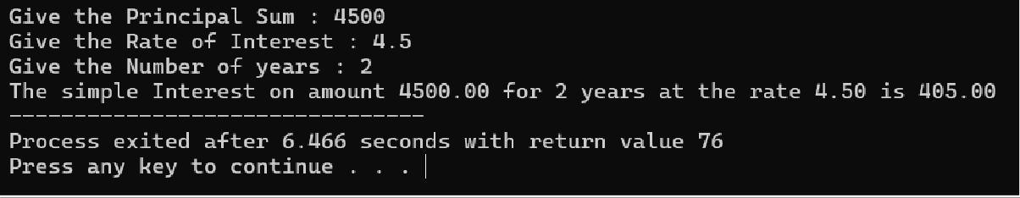

**OUTPUT – 3:**

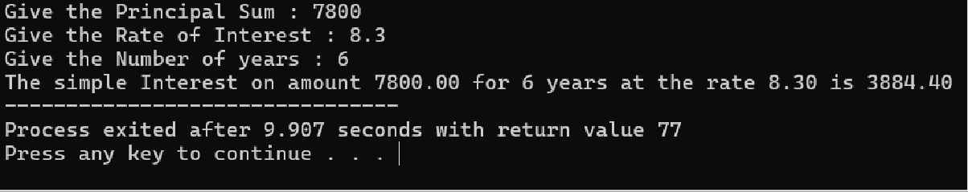

## Set A. Apply all the three program development steps for the following examples.

* + 1. Accept dimensions of a cylinder and print the surface area and volume (Hint: surface area = 2πr2 + 2πrh, volume = πr2h)

Program:

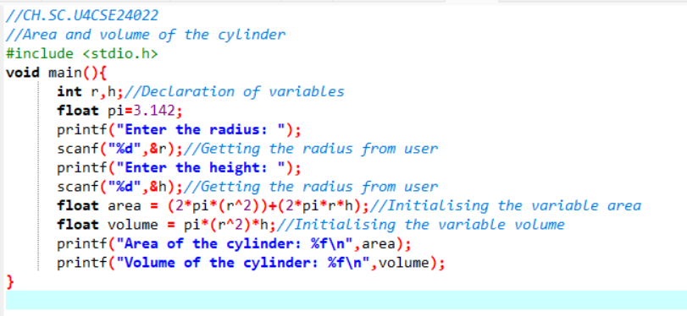

Output:

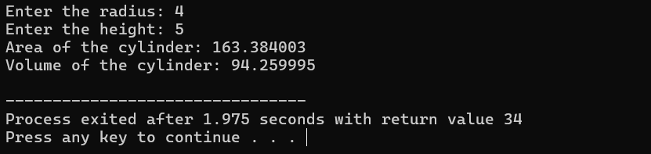

* + 1. Accept temperatures in Fahrenheit (F) and print it in Celsius(C) and Kelvin (K) (Hint: C=5/9(F-32), K = C + 273.15)

Program:

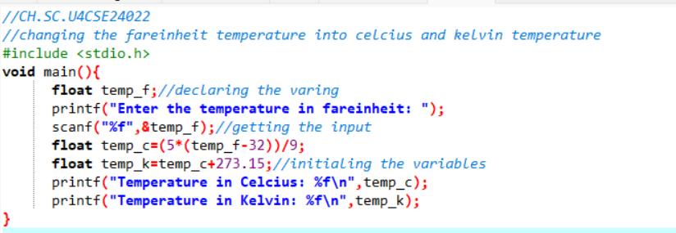

Output:

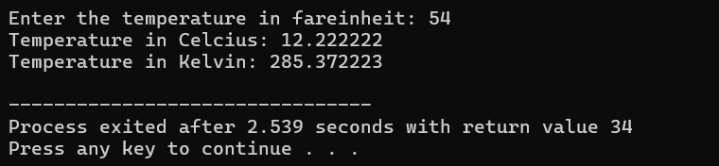

* + 1. Accept initial velocity (u), acceleration (a) and time (t). Print the final velocity (v) and distance (s) travelled. (Hint: v = u + at, s = u + at2)

Program:

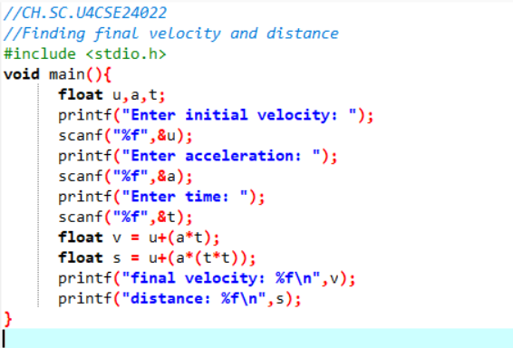

Output:

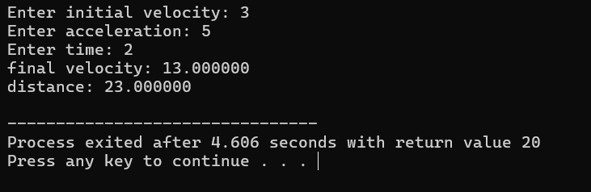

Program:

* + 1. Accept inner and outer radius of a ring and print the perimeter and area of the ring

(Hint: perimeter = 2 π (a+b) , area = π (a2-b2) )

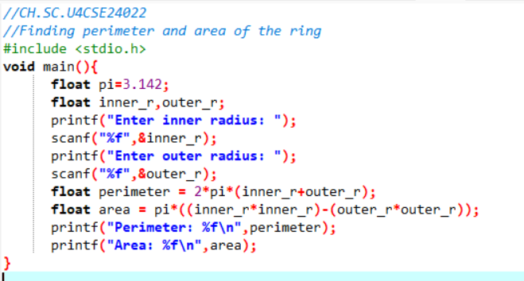

Output:

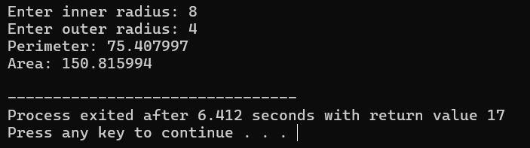

* + 1. Accept two numbers and print arithmetic and harmonic mean of the two numbers (Hint: AM= (a+b)/2 , HM = ab/(a+b) )

Program:

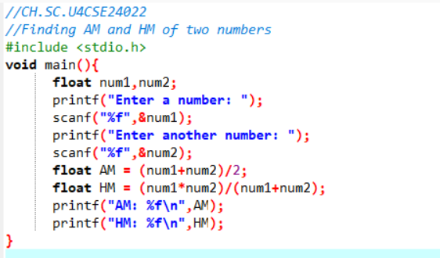

Output:

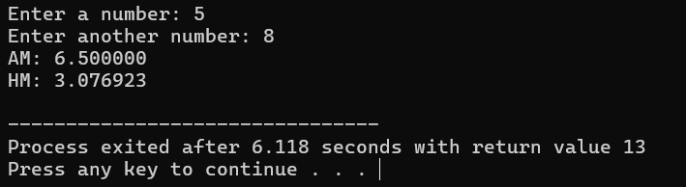

Program:

* + 1. Accept three dimensions length (l), breadth(b) and height(h) of a cuboid and print surface area and volume (Hint : surface area=2(lb+lh+bh ), volume = lbh )

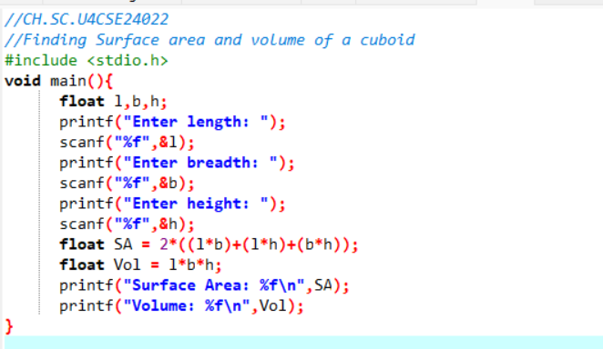

Output:

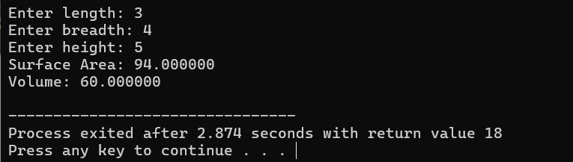

* + 1. Accept a character from the keyboard and display its previous and next character in order. Ex. If the character entered is ‘d’, display “The previous character is c”, “The next character is e”.

Program:

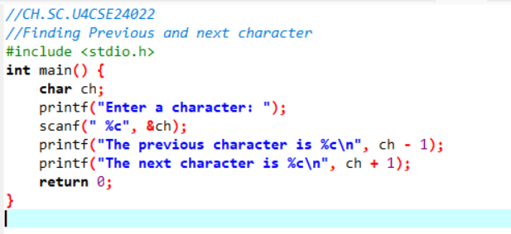

Output:

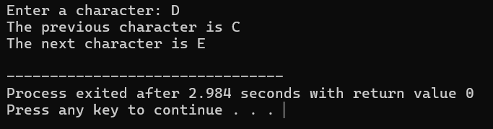

* + 1. Accept a character from the user and display its ASCII value.

Program:

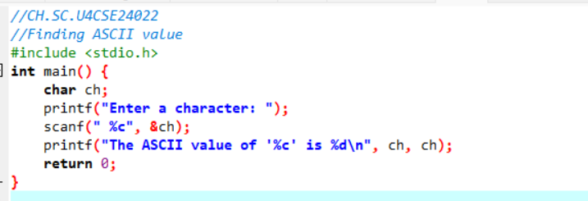

Output:

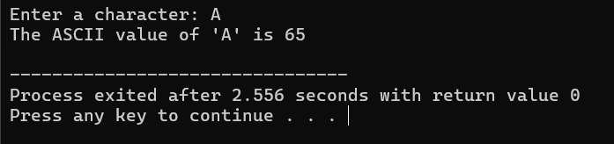

## Set B . Apply all the three program development steps for the following examples.

* + - 1. Accept the x and y coordinates of two points and compute the distance between the two points.

Program:

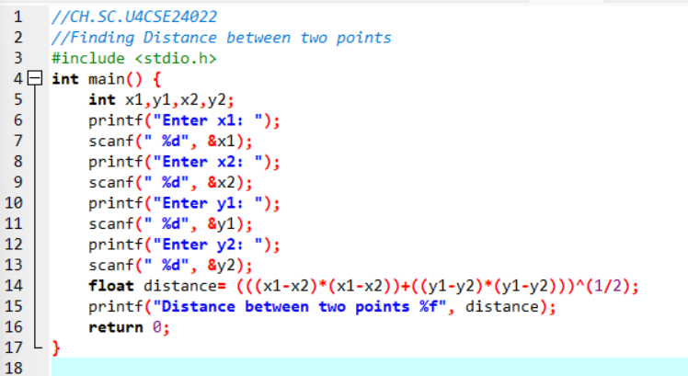

Output:

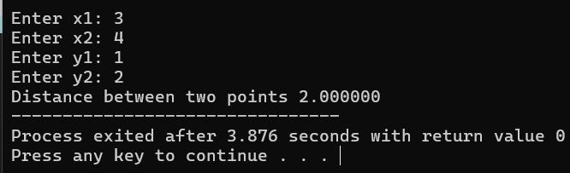

* + - 1. Accept two integers from the user and interchange them. Display the interchanged numbers.

Program:

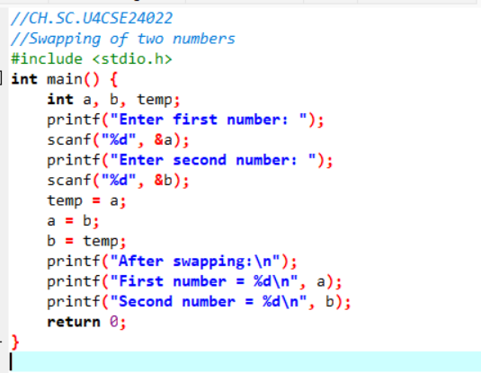

Output:

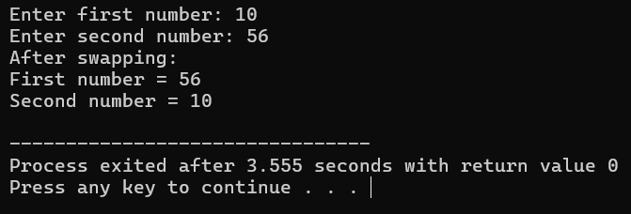

* + - 1. A cashier has currency notes of denomination 1, 5 and 10. Accept the amount to be withdrawn from the user and print the total number of currency notes of each denomination the cashier will have to give.

Program:

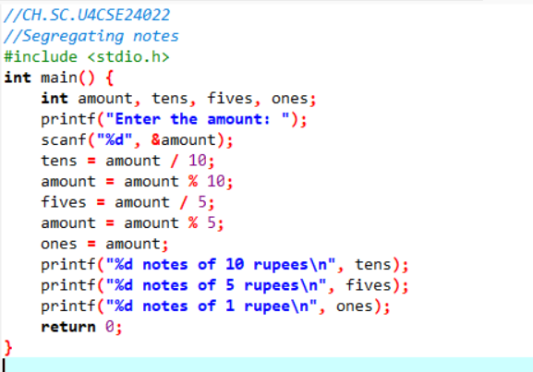

Output:

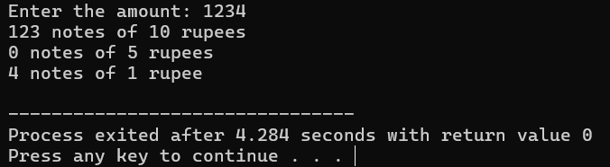

|  |  |  |
| --- | --- | --- |
| **Assignment Evaluation:** |  | |
| 0: Not Done [ ] | 1: Incomplete [ ] | 2: Late Complete [ ] |
| 3: Needs Improvement [ ] | 4: Complete | 5: Well Done [ ] |

## Viva Questions:

What is pseudocode and why is it used in problem-solving?

Ans: Pseudocode is an informal, human-readable description of a computer program or algorithm, written in plain language, that uses the structural conventions of programming languages without strict syntax rules. It's used in problem-solving as a planning tool to outline the logic of a solution before writing actual code, making it easier to understand, debug, and communicate the solution.

Write pseudocode to find the largest of three numbers.

How would you write a pseudocode for calculating the factorial of a number? Explain the difference between sequence, selection, and iteration in pseudocode.

What are the advantages and limitations of using pseudocode before writing actual code?

## Activity Sheet 2 Date:

Decision Making Control Structures

## Exercise 1:

**Objective:**

To demonstrate use of decision-making statements such as if and if-else.

## Reading:

You should read following topics before starting this exercise

1. Different types of decision-making statements available in C.
2. Syntax for these statements.

During problem solving, we come across situations when we have to choose one of the alternative paths depending upon the result of some condition. Condition is an expression evaluating to true or false. This is known as the Branching or decision-making statement. Several forms of If and else constructs are used in C to support decision-making.

* 1. if statements
  2. 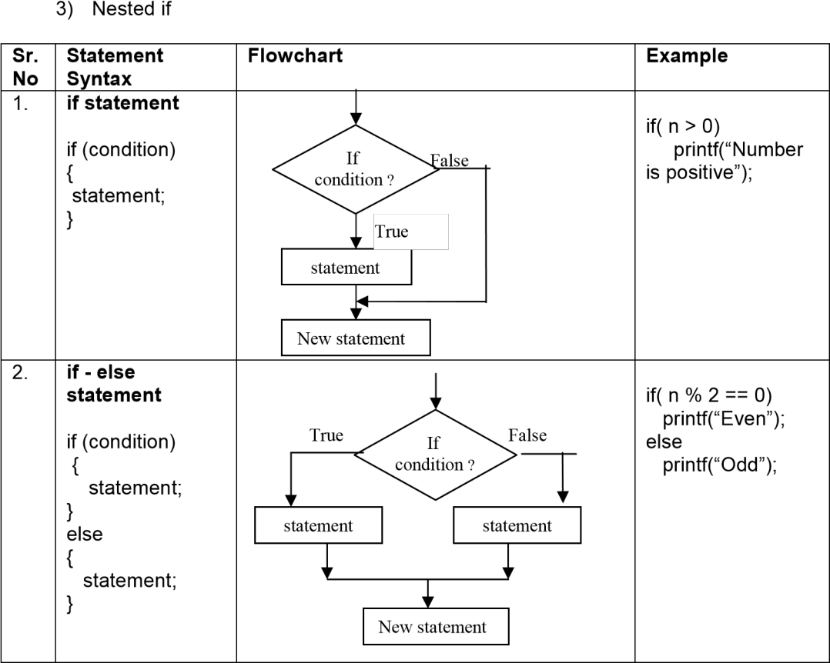if – else

|  |  |  |  |
| --- | --- | --- | --- |
| 3. | Nested if  if (condition)  {  if (condition) { statement;} else  { statement;}  }  else  {  if (condition)  { statement;  } else  { statement; }  } | False a>=b True b>= c  False True False a>=c True c is b is c is a is  max max max max | If ( a >= b)  {  if ( a >= c)  printf(“ %d is maximum”,a);  else  printf(“ %d is maximum”,c);  }  else  {  if ( b >= c) printf(“ %d is maximum”,b);  else  printf(“ %d is maximum”,c);  } |

* + - 1. Sample program- to check whether a number is within range.

|  |  |  |
| --- | --- | --- |
| **Step 1: Writing the**  **Algorithm** | **Step 2: Draw the flowchart** | **Step 3: Writing Program** |
| Algorithm Range Begin  Input llimit, ulimit Input num  If n≥llimit and  n≤ulimit then  Output “in range”  Else  Output “not in  range”  End | start  Read number  False  If(n in range)  True  Number is within range  Number is of range  stop | #include <stdio.h> main( )  {  /* variable declarations */ int n;  int llimit=50, ulimit = 100;  /* prompting and accepting input */ printf(“Enter the number”); scanf(“%d”,&n);  if(n>=llimit && n <= ulimit)  printf(“Number is within range”);  else  printf(“Number is out of range”);  } |

## Self Activity

1. Execute the following program for five different values and fill in the adjoining table

|  |  |  |  |  |
| --- | --- | --- | --- | --- |
| main()  {  int n;  printf(“Enter no.”);  scanf(“%d”,&n);  if(n% ==0)  printf(“divisible);  else  printf(“not divisible ”);  } |  | n | output |  |
|  |  |  |
|  |  |  |
|  |  |  |
|  |  |  |
|  |  |  |
|  | |  |

1. Type the above sample program 4 and execute it for the following values.

|  |  |
| --- | --- |
| n | Output message |
| 50 |  |
| 100 |  |
| 65 |  |
|  |  |
|  |  |

1. Using the sample code 3 above write the complete program to find the maximum of three numbers and execute it for different set of values.

Program:

## Set A: Apply all the three program development steps for the following examples.

1. Write a program to accept an integer and check if it is even or odd.

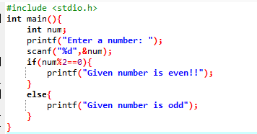

Output:

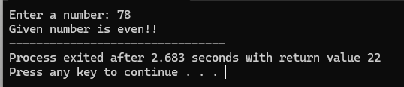

1. Write a program to accept three numbers and check whether the first is between the other two numbers. Ex: Input 20 10 30. Output: 20 is between 10 and 30

Program:

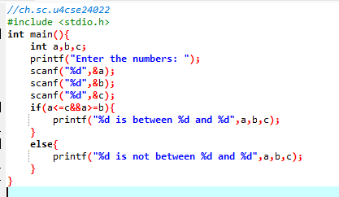

Output:

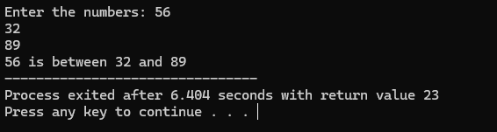

1. Accept a character as input and check whether the character is a digit.

(Check if it is in the range ‘0’ to ‘9’ both inclusive)

Program:

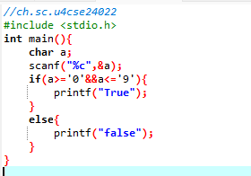Output:

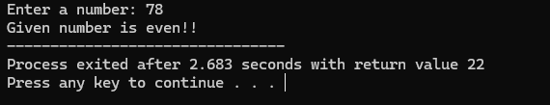

1. Write a program to accept a number and check if it is divisible by 5 and 7.

Program:

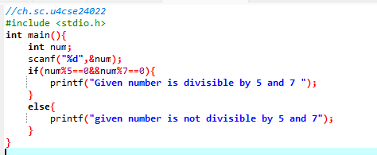

Output:

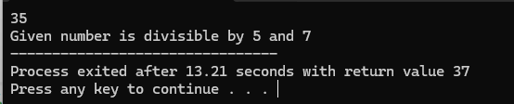

1. Write a program, which accepts annual basic salary of an employee and calculates and displays the Income tax as per the following rules. ***

Basic: < 1,50,000 Tax = 0

1,50,000 to 3,00,000 Tax = 20%

> 3,00,000 Tax = 30%

Program:

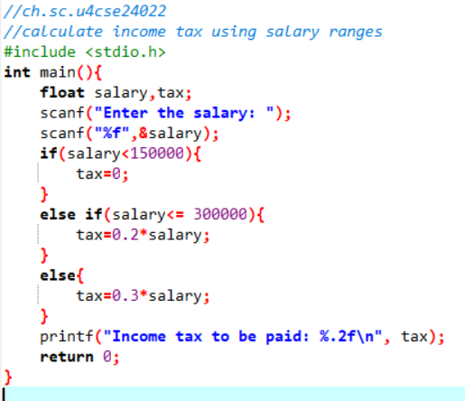

Output:

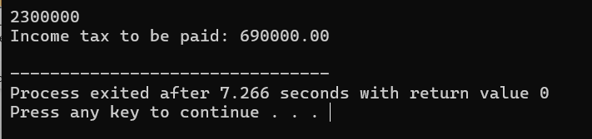

1. Accept a character from the user and check whether the character is a vowel or consonant. (Hint: a,e,i,o,u, A, E, I, O, U are vowels)

Program:

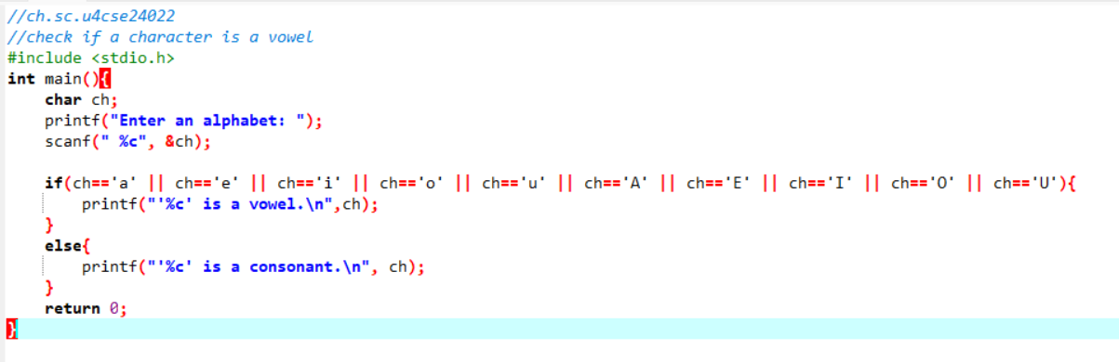

Output:

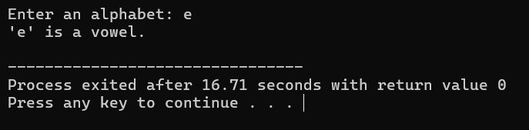

1. Accept any year as input through the keyboard. Write a program to check whether the year is a leap year or not. (Hint leap year is divisible by 4 and not by 100 or divisible by 400)

Program:

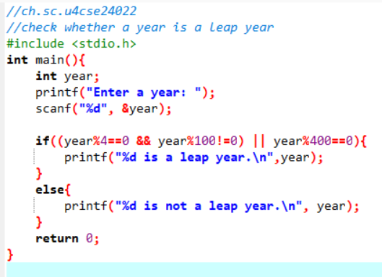

Output:

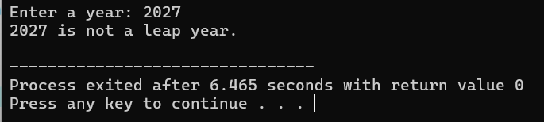

## Set B: Apply all the three program development steps for the following examples.

* 1. Write a program to check whether given character is a digit or a character in lowercase or uppercase alphabet. (Hint ASCII value of digit is between 48 to 58 and Lowercase characters have ASCII values in the range of 97 to122, uppercase is between 65 and 90)

Program:

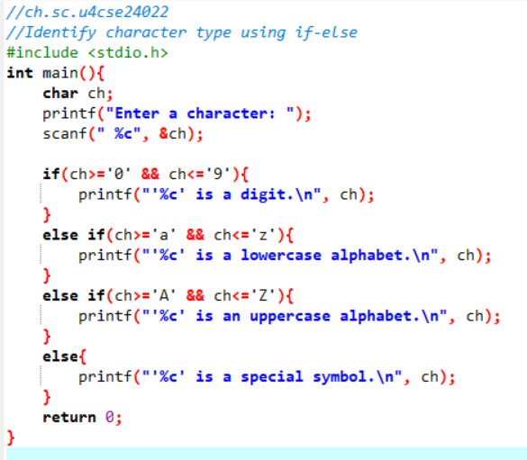

Output:

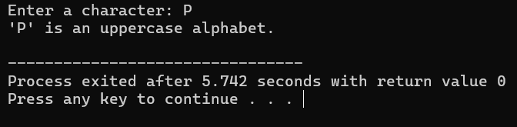

* 1. Accept the x and y coordinate of a point and find the quadrant in which the point lies.

Program:

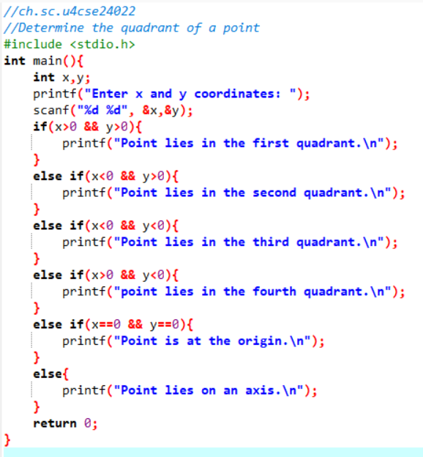

Output:

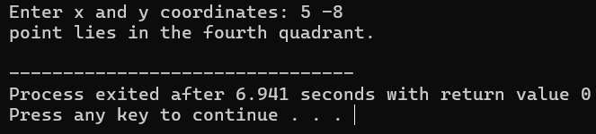

* 1. Write a program to calculate the roots of a quadratic equation. Consider all possible cases. Accept the cost price and selling price from the keyboard. Find out if the seller has made a profit or loss and display how much profit or loss has been made.

Program:

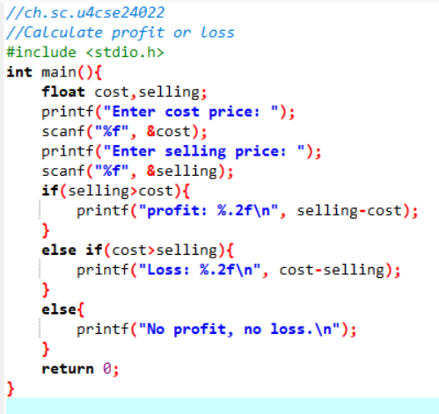

Output:

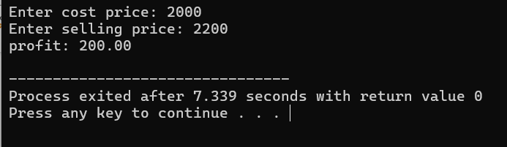

* 1. Write a program to accept marks for three subjects. Calculate the average and also display the class obtained. (Distinction – above Class I – above %, class II –

% to %, pass class – % to % and fail otherwise)

Program:

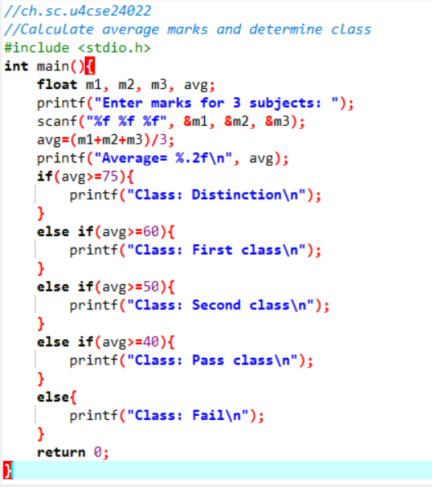

Output:

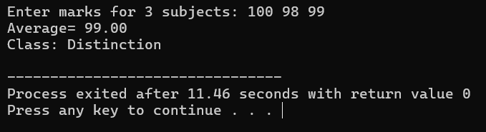

|  |  |  |
| --- | --- | --- |
| **Assignment Evaluation** |  | |
| 0: Not Done [ ] | 1: Incomplete [ ] | 2: Late Complete [ ] |
| 3: Needs Improvement [ ] | 4: Complete | 5: Well Done [ ] |

## Viva Questions

1. Give an application of nested if else statements in C Programming.

Ans:

if (marks >= 90) {

printf("Grade: A"); }

else if (marks >= 75) {

if (marks >= 85)

printf("Grade: B+");

else

printf("Grade: B");

}

else { printf("Grade: C");

}

1. How would you handle missed cases in conditional statements.

Ans:

Missed cases can be handled by: Using a final else block to catch all unhandled scenarios. Validating inputs before processing. Logging unexpected values for debugging.

1. Can you describe a situation where the use of a ternary operator would be more appropriate than a traditional if else statement.

Ans:

int max = (a > b) ? a : b;

1. How do you incorporate error handling within your conditional statement.

Ans:

Error handling can be done using if conditions to check for invalid inputs, null pointers, or failed operations, and responding accordingly.

Example:

if (denominator == 0) {

printf("Error: Division by zero is not allowed.\n");

} else {

result = numerator / denominator;

}

**Date:**

**Exercise 2:**

**Objective:**

To demonstrate decision making statements (switch case)

## Reading:

You should read following topics before starting this exercise

1. Different types of decision-making statements available in C.
2. Syntax for switch case statements.

The control statement that allows us to make a decision from the number of choices is called a switchcase statement. It is a multi-way decision making statement.

1. **Usage of switch statement**

|  |  |  |
| --- | --- | --- |
| Statement Syntax | Flowchart | Example |
| switch(expression)  {  case value1: block1;  break; case value2: block2;  break;  .  .  .  default: default block; break;  } | start  case 1 True Block 1 False  True  case 2 Block 2  False  True  case 3 Block 3  False  True  case 4 Block 4  False  Default Block  stop | switch (color)  {  case ’r’ : case ’R’ :  printf (“RED”);  break;  case ’g’ : case ’G’ :  printf (“GREEN”);  break;  case ’b’ : case ’B’ :  printf (“BLUE”);  break; default :  printf (“INVALID COLOR”);  } |

1. The switch statement is used in writing menu driven programs where a menu displays several options and the user gives the choice by typing a character or number. A Sample program to display the selected option from a menu is given below.

|  |  |  |  |
| --- | --- | --- | --- |
| **Step 1: Writing the**  **Algorithm** | **Step 2: Draw the flowchart** | | **Step 3: Writing Program** |
| Algorithm Menu Begin  Output menu Read choice  Execute statements depending on choice End | start  Display Options  Read choice  True  case 1 Statement 1  False  True  case 2 Statement 2  False  True  case 3 Statement 3  False True | | #include <stdio.h> main( )  {  /* variable declarations */ int choice;  /* Displaying the Menu */ printf(“\n 1. Option 1\n”); printf(“ 2. Option 2\n”); printf(“ 3. Option 3\n”); printf(“Enter your choice”); scanf(“%d”,&choice); switch(choice)  {  case 1: printf(“Option 1 is selected”);  break;  case 2: printf(“Option 2 is selected”);  break;  case 3: printf(“Option 3 is selected”);  break;  default: printf(“Invalid choice”);  }  } |
| Default statement |  |
| stop | |

## Self Activity

1. Write the program that accepts a char–type variable called color and displays appropriate message using the sample code 1 above. Execute the program for various character values and fill in the following table. Modify the program to include all rainbow colours

|  |  |
| --- | --- |
| **Input character** | **Output Message** |
| V |  |
| I |  |
| B |  |
| g |  |
| R |  |
| y |  |

## Set A: Apply all the three program development steps for the following examples.

* 1. Accept a single digit from the user and display it in words. For example, if digit entered is 9, display Nine.

Program: 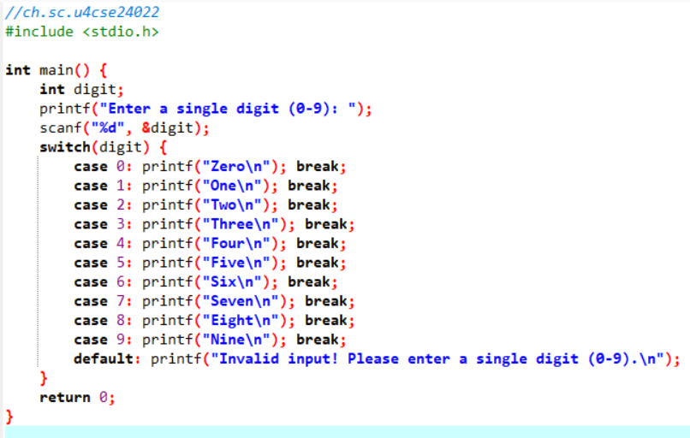

Output:

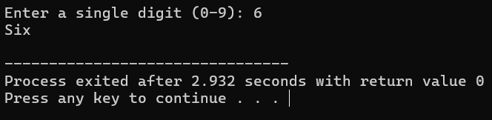

* 1. Write a program, which accepts two integers and an operator as a character (+ - * /), performs the corresponding operation and displays the result.

Program:

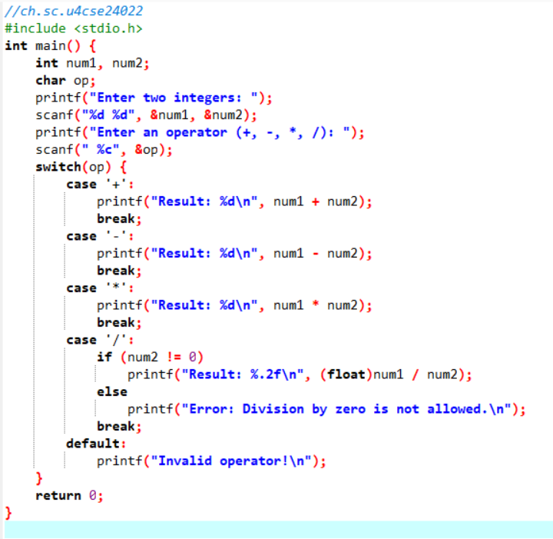

Output:

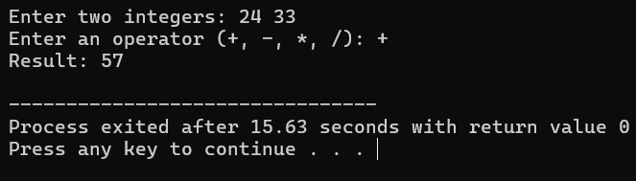

* 1. Accept two numbers in variables x and y from the user and perform the following operations

|  |  |
| --- | --- |
| **Options** | **Actions** |
| 1. Equality | Check if x is equal to y |
| 2. Less Than | Check if x is less than y |
| 3. Quotient and Remainder | Divide x by y and display the quotient and remainder |
| 4. Range | Accept a number and check if it lies between x and y (both inclusive) |
| 5. Swap | Interchange x and y |

Program:

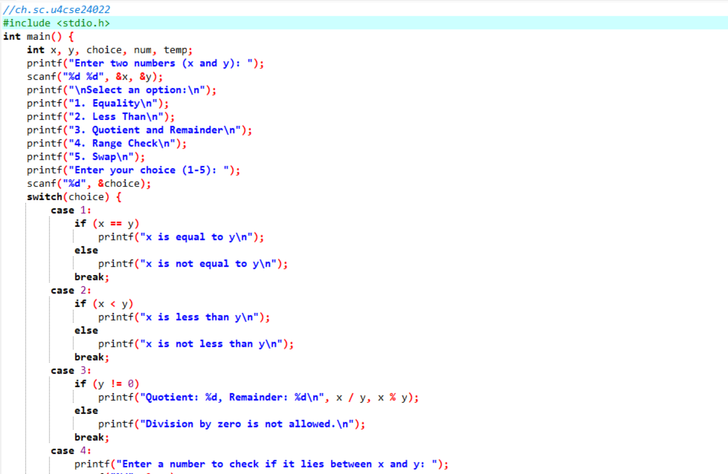

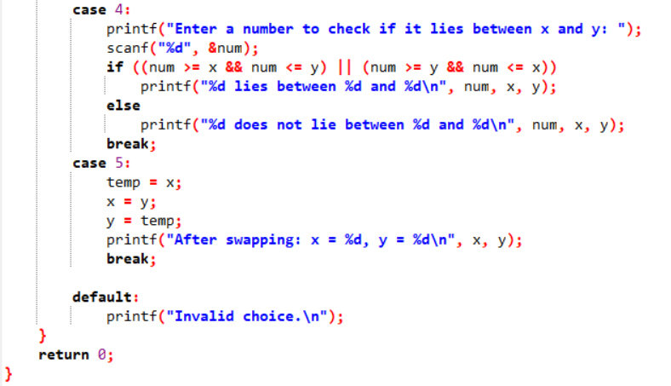

Output:

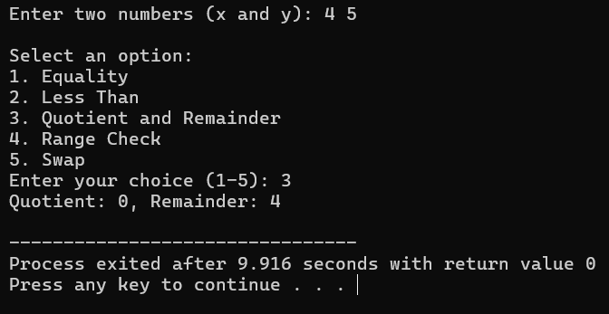

Program:

## Set B: Apply all the three program development steps for the following examples

1. Accept radius from the user and write a program having menu with the following options and corresponding actions

|  |  |
| --- | --- |
| **Options** | **Actions** |
| 1. Area of Circle | Compute area of circle and print |
| 2. Circumference of Circle | Compute Circumference of circle and print |
| 3. Volume of Sphere | Compute Volume of Sphere and print |

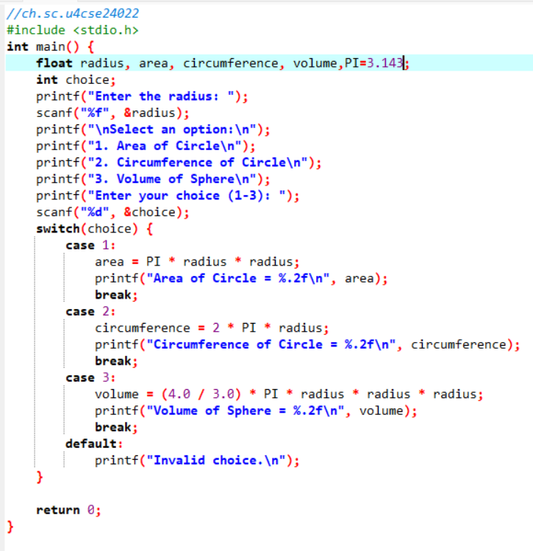

Output:

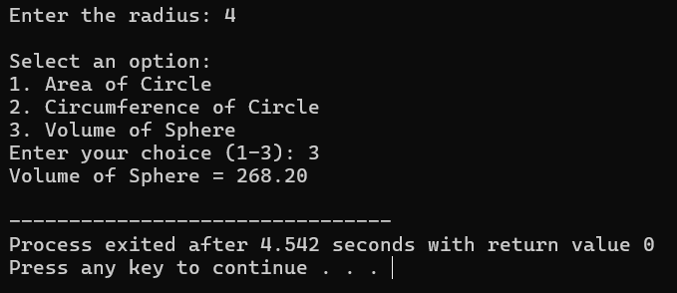

1. Write a program having a menu with the following options and corresponding actions

|  |  |
| --- | --- |
| **Options** | **Actions** |
| 1. Area of square | Accept length, Compute area of square and print |
| 2. Area of Rectangle | Accept length and breadth, Compute area of rectangle and print |
| 3. Area of triangle | Accept base and height, Compute area of triangle and print |

Program:

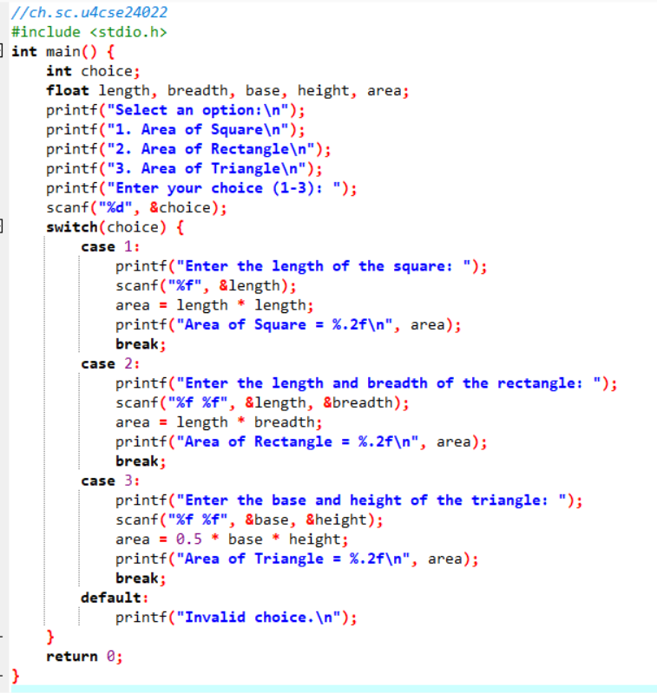

Output:

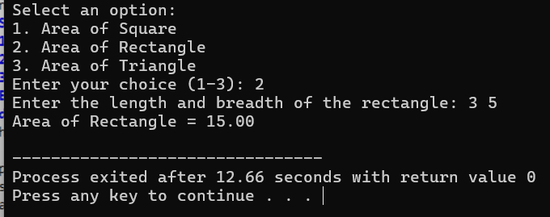

|  |  |  |
| --- | --- | --- |
| **Assignment Evaluation** |  | |
| 0: Not Done [ ] | 1: Incomplete [ ] | 2: Late Complete [ ] |
| 3: Needs Improvement [ ] | 4: Complete | 5: Well Done [ ] |

# Activity Sheet 3 Date:

Loop Control Structures

## Exercise 1:

**Objective:**

To demonstrate use of simple loops.

## Reading:

You should read following topics before starting this exercise

1. Different types of loop structures in C.
2. Syntax and usage of these statements.

We need to perform certain actions repeatedly for a fixed number of times or till some condition holds true. These repetitive operations are done using loop control statements. The types of loop structures supported in C are

* 1. while statement
  2. do-while statement

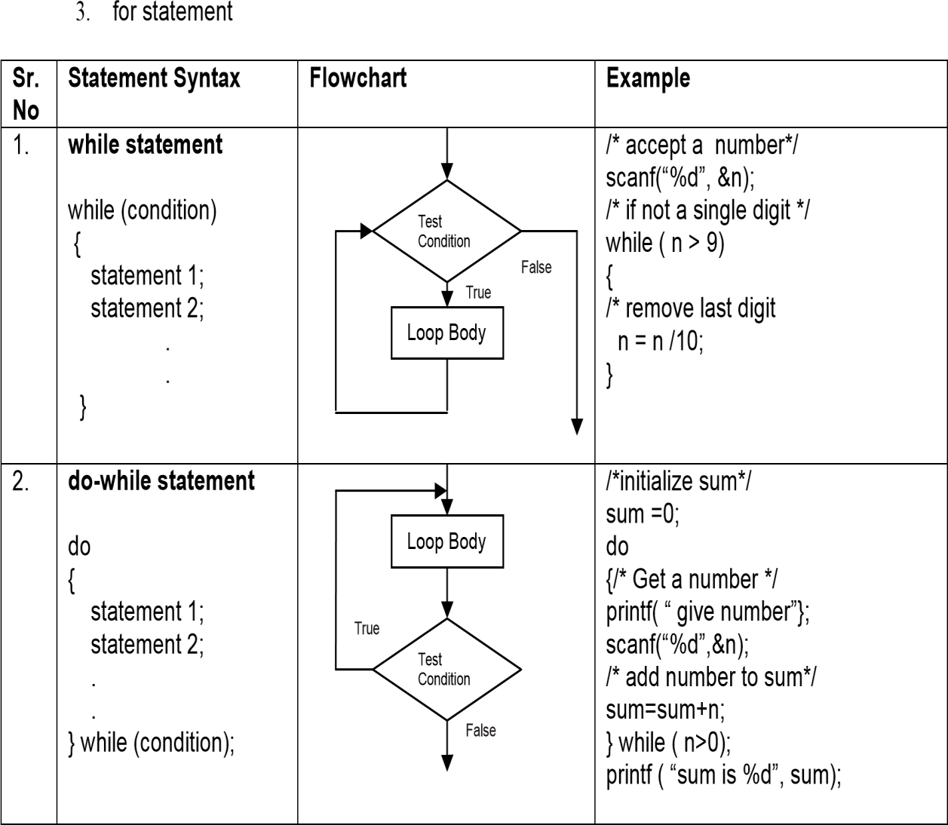

|  |  |  |  |
| --- | --- | --- | --- |
| 3. | **for statement**  for (expr1; expr2; expr3)  {  statement 1  .  .  }  expr1 = initialization expression  expr2 = loop condition expr3 = alteration expression which alters the loop variable | expr1  Test False expr2  True  Loop Body Expr3 | /* display first 10 multiples of 2 */  {  for(i=1; i <= 10; i++)  printf (“2 X %d = %d\n”, i, 2*i);  } |

1. Sample program- to print sum of 1+2+3+….n.

|  |  |  |
| --- | --- | --- |
| **Step 1: Writing the Algorithm** | **Step 2: Draw the flowchart** | **Step 3: Writing Program** |
| Algorithm SumofN Begin  Input n Sum=0  While n>0 do sum-sum+n  n=n-1 Output sum  End |  | #include <stdio.h> main( )  {  /* variable declarations */ int sum = 0, n;  printf(“enter the value of n : “); scanf(“%d”,&n);  while (n>0)  {  sum = sum + n; n--;  }  printf(“\n The sum of numbers is %d”, sum);  } |

1. Sample program- To read characters till EOF (Ctrl+Z) and count the total number of characters entered.

|  |  |  |
| --- | --- | --- |
| **Step 1 : Writing the Algorithm** | **Step 2 : Draw the flowchart** | **Step 3 : Writing Program** |
| Algorithm CharCount Begin  Count=0 Input ch  While ch ≠EOF do Count=count+1 Input ch  Output count End | start count = 0  Read ch  Ch=EOF  ?  False  Count = count+1  Print count  stop | #include <stdio.h> main( )  {  char ch; int count=0; while((ch=getchar())!=EOF) count++;  printf(“Total characters =%d”, count);  } |

## Self-Activity

* 1. Execute example 1 given above. Execute the program for different values.
  2. Write a program that accepts numbers continuously as long as the number is positive and prints the sum of the numbers read. Refer example code 2 given above.

Execute the program for different values.

* 1. Write a program to accept n and display its multiplication table. Refer to sample code 3 given above.
  2. Type the sample program to print sum of first n numbers and execute the program for different values of n.
  3. Write a program to accept characters till the user enters EOF and count number of times ‘a’

Is entered. Refer to sample program 5 given above.

## Set A . Apply all the three program development steps for the following examples.

* + 1. Write a program to accept an integer n and display all even numbers upto n.

Program:

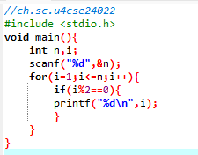

Output:

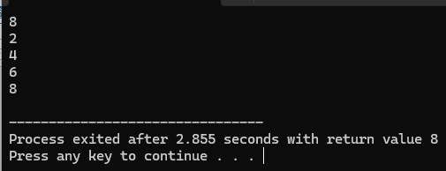4

* + 1. Accept two integers x and y and calculate the sum of all integers between x and y (both inclusive)

Program:

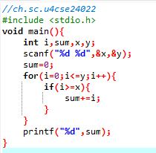

Output:

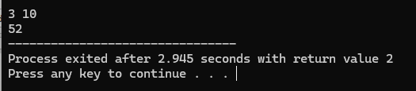

* + 1. Write a program to accept two integers x and n and compute xn

Program:

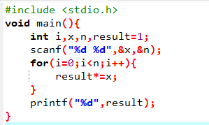

Output:

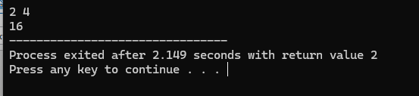

* + 1. Write a program to accept a character, an integer n and display the next n characters.

Program:

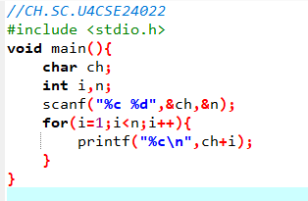

Output:

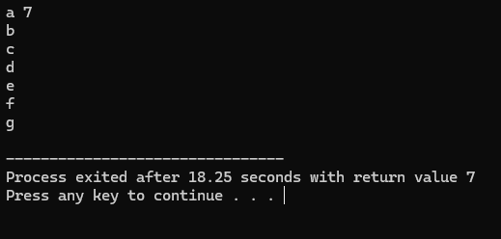

* + 1. Write a program to accept an integer and check if it is prime or not.

Program:

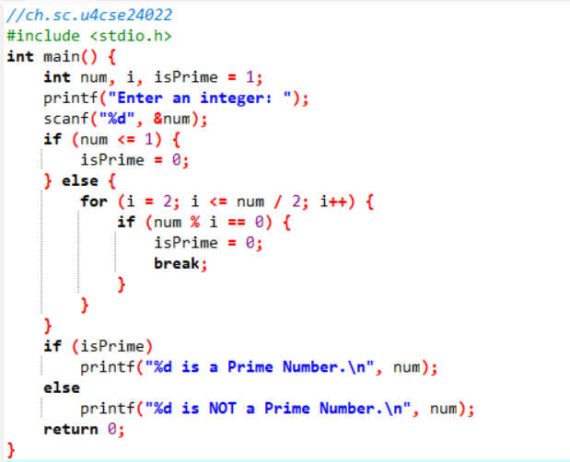

Output:

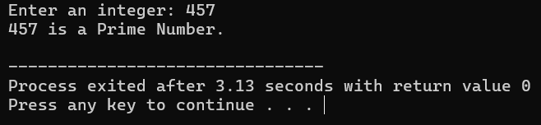

* + 1. Write a program to accept an integer, count number of digits and calculate sum of digits in the number. Example: Number = 1234 Output: Digits = 4, Sum = 10

Program:

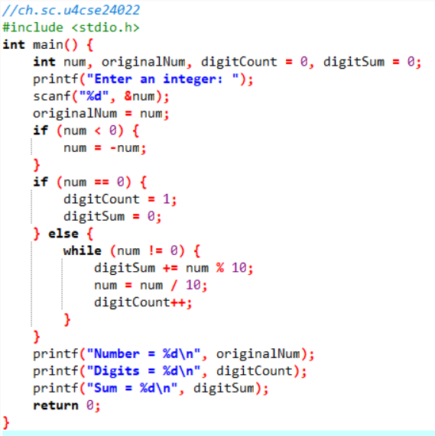

Output:

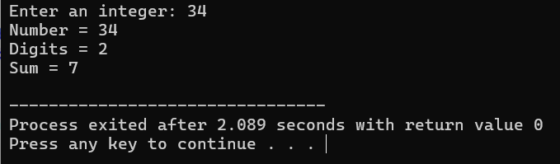

* + 1. Write a program to accept an integer and reverse the number. Example: Input: 546, Reverse = 645.

Program:

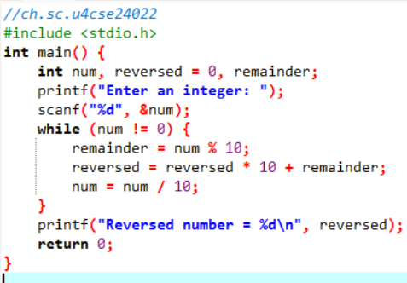

Output:

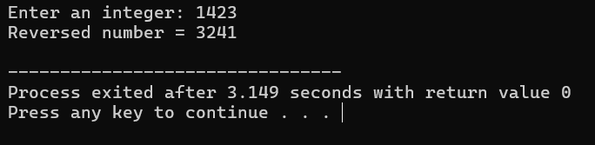

Program:

## Set B. Apply all the three program development steps for the following examples.

1. Write a program to display the first n Fibonacci numbers. (1 1 2 3 5 ……)

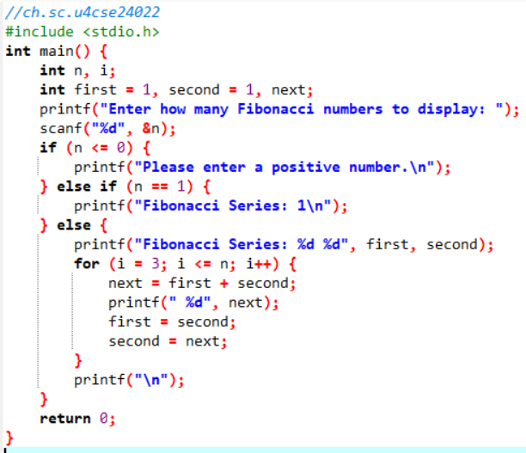

Output:

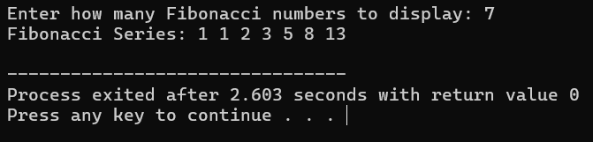

1. Write a program to accept real number x and integer n and calculate the sum of first n terms of the series x+ 3x+5x+7x+…

Program:

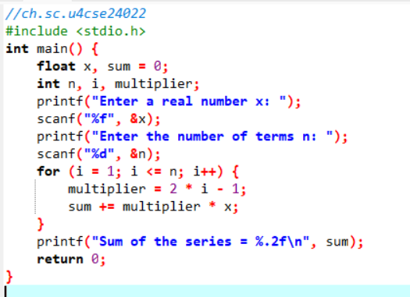

Output:

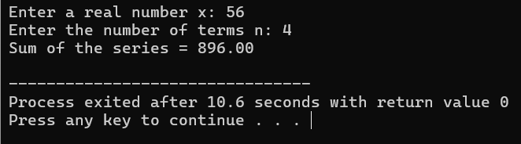

Program:

1. Write a program to accept real number x and integer n to calculate sum of first n terms of the Series 1 2 3

x ~~+~~  x 2 + x3 + ……

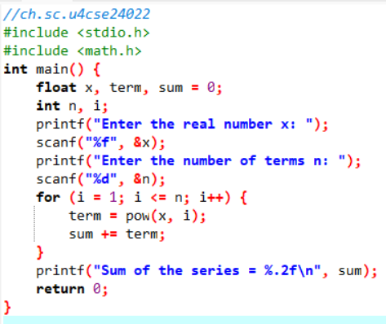

Output:

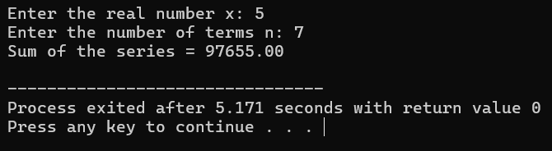

1. Write a program to accept characters till the user enters EOF and count number of alphabets and digits entered. Refer to sample program 5 given above.

Program:

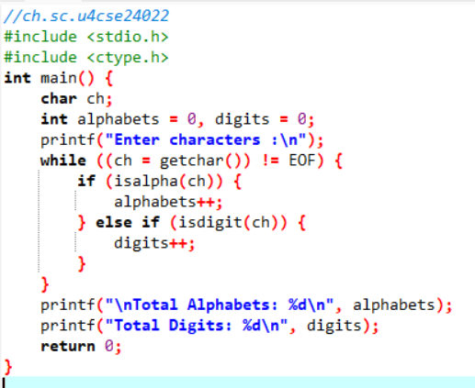

Output:

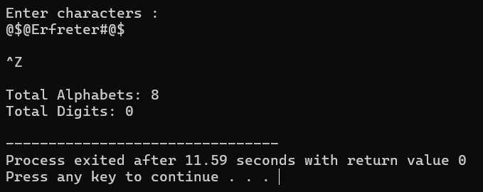

1. Write a program, which accepts a number n and displays each digit in words. Example: 6702 Output = Six-Seven-Zero-Two.

(Hint: Reverse the number and use a switch statement)

Program:

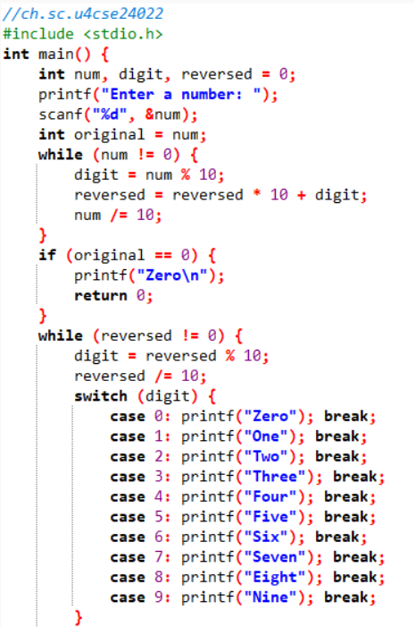

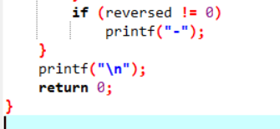

Output:

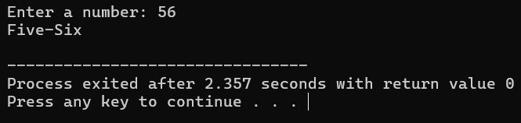

|  |  |  |
| --- | --- | --- |
| **Assignment Evaluation** |  | |
| 0: Not Done [ ] | 1: Incomplete [ ] | 2: Late Complete [ ] |
| 3: Needs Improvement [ ] | 4: Complete [ ] | 5: Well Done [ ] |

## Exercise 2 Date:

**Objective:**

To demonstrate use of nested loops

## Reading

In the previous exercise, you used while, do-while and for loops. You should read following topics before starting this exercise

* 1. Different types of loop structures in C.
  2. Syntax for these statements.
  3. Usage of each loop structure

Nested loop means a loop that is contained within another loop. Nesting can be done upto any levels. The inner loop has to be completely enclosed in the outer loop. No overlapping of loops is allowed.

|  |  |  |
| --- | --- | --- |
| **Sr. No** | **Format** | **Sample Program** |
| 1. | Nested for loop | #include <stdio.h> void main()  {  int n , line_number , number; printf(“How many lines: ”); scanf(“%d”,&n);  for(line_number =1 ;line_number <=n; line_number++ )  {  for(number = 1; number <= line_number; number++)  printf (“%d\t”, number);  printf (“\n”);  }  } |
|  | for(exp1; exp2 ; exp3) |
|  | { …………………… |
|  | for(exp11; exp12 ; exp13) |
|  | { …………………… |
|  | } |
|  | ……………………. |
|  | } |

|  |  |  |
| --- | --- | --- |
| 2. | Nested while loop / do while loop | #include <stdio.h> void main( )  {  int n , sum;  printf(“Give any number ”); scanf(“%d”,&n);  do  {  sum =0;  printf(“%d --->”,n); while ( n>0)  {  sum +=n%10; n= n/10;  }  n=sum;  } while( n >9); printf ( “ %d” , n);  } |
|  | while(condition1) |
|  | { …………………… |
|  | while(condition2) |
|  | { …………………… |
|  | } |
|  | ……………………. |
|  | } |
|  | do |
|  | { …………………… |
|  | while(condition1) |
|  | { ……………….. |
|  | } |
|  | ………………. |
|  | } while (condition2); |

## Self-Activity

1. The Sample program 1 displays n lines of the following triangle. Type the program and execute it for different values of n.

1

|  |  |  |  |
| --- | --- | --- | --- |
| 1 | 2 |  |  |
| 1 | 2 | 3 |
| 1 | 2 | 3 | 4 |

1. Modify the sample program 1 to display n lines of the Floyd’s triangle as follows (here n=4).

1

|  |  |  |  |
| --- | --- | --- | --- |
| 2 | 3 |  |  |
| 4 | 5 | 6 |
| 7 | 8 | 9 | 10 |

1. The sample program 2 computes the sum of digits of a number and the process is repeated till the number reduces to a single digit number. Type the program and execute it for different values of n and give the output

|  |  |
| --- | --- |
| **Input number** | **Output** |
| 6534 |  |
| 67 |  |
| 8 |  |
|  |  |

Program:

## Set A . Write C programs for the following problems.

1. Write a program to display all prime numbers between and .

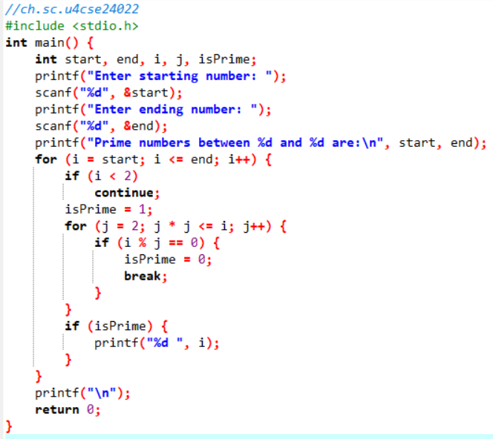

Output:

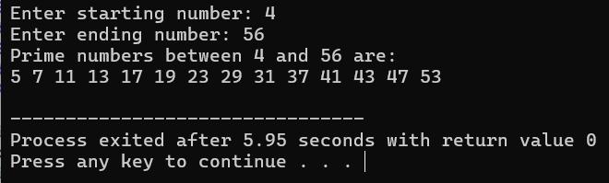

1. Write a program to display multiplication tables from to having n multiples each. The output should be displayed in a tabular format. For example, the multiplication tables of 2 to 9 having 10 multiples each is shown below.

2 × 1 = 2 3 × 1 = 3 ………….9 × 1 = 9

2 × 2 = 4 3 × 2 = 6…………..9 × 2 = 18

…………. ………….

2 × 10 = 20 3 × 10 = 30………..9 × 10 = 90

Program:

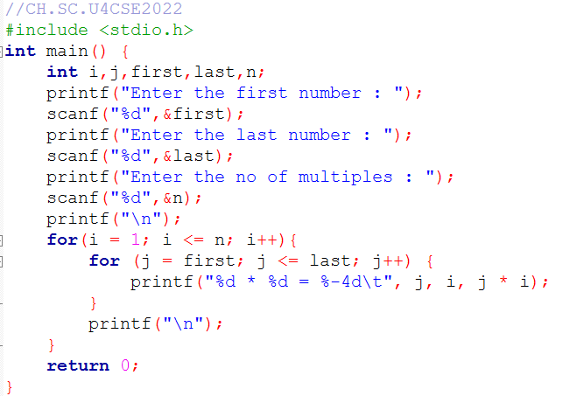

Output:

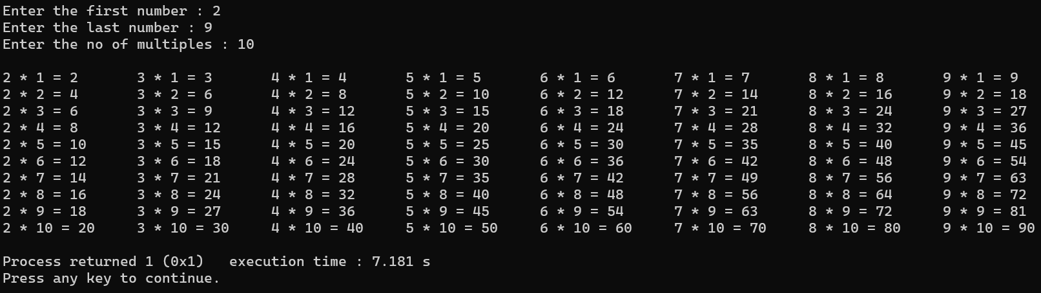

Program:

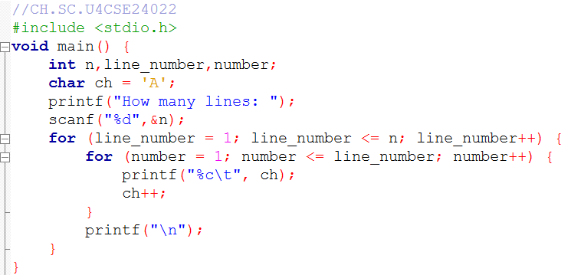3. Modify the sample program 1 to display n lines as follows (here n=4).

A

B C

D E F

G H I J

Output:

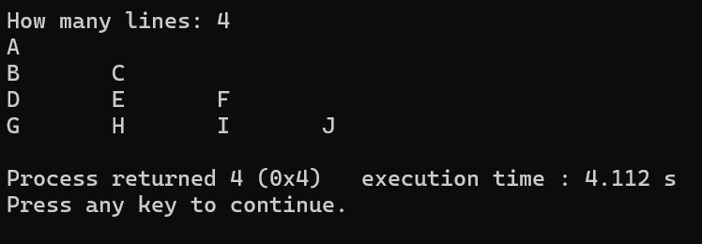

## Set B. Write C programs for the following problems.

1. Write a program to display all Armstrong numbers between 1 and 500. (An Armstrong number is a number such that the sum of cube of digits = number itself. Ex. 153 = 1*1*1 + 5*5*5 + 3*3*3

Program:

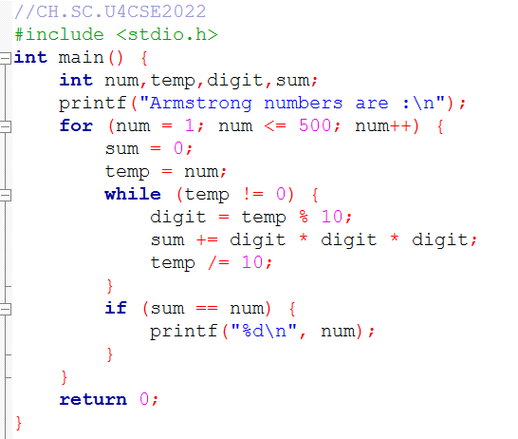

Output:

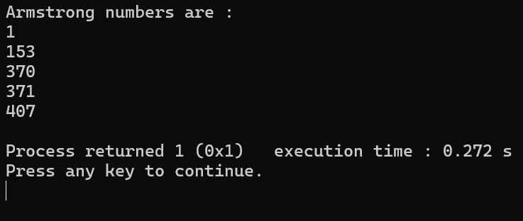

1. Accept n numbers and display the number having the maximum sum of digits.

Program:

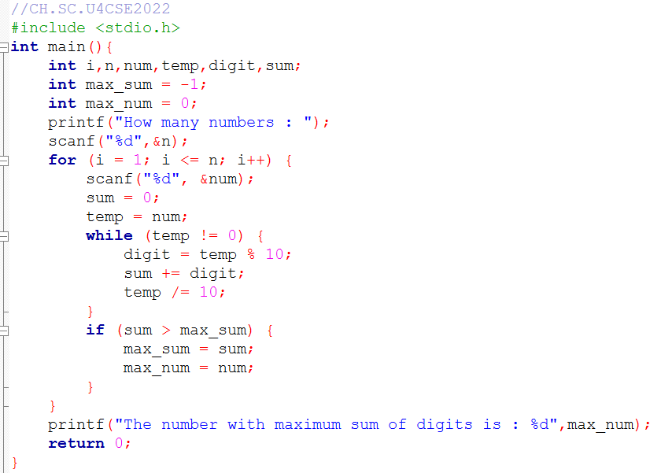

Output:

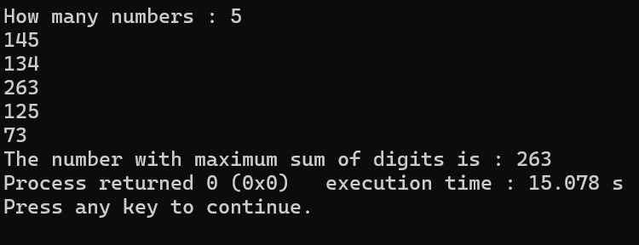

1. Display all perfect numbers below 500. [A perfect number is a number, such that the sum of its factors is equal to the number itself]. Example: 6 (1 + 2 + 3), 28 (1+2+4+7+14)

Program:

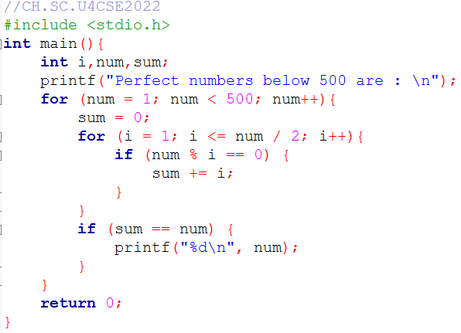

Output:

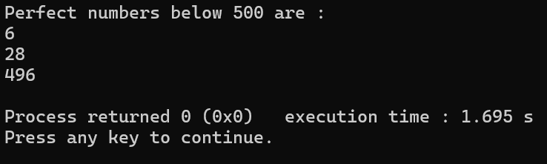

|  |  |  |
| --- | --- | --- |
| **Assignment Evaluation** |  | |
| 0: Not Done [ ] | 1: Incomplete [ ] | 2: Late Complete [ ] |
| 3: Needs Improvement [ ] | 4: Complete [ ] | 5: Well Done [ ] |

# Activity Sheet 4 Date:

Functions (User Defined functions, Library functions and Recursion).

## Exercise 1:

To demonstrate menu driven programs and use of standard library functions

## Reading

You should read following topics before starting this exercise

1. Use of switch statement to create menus as in exercise3
2. Use of while and do while loops as in

**ctype.h :** contains function prototypes for performing various operations on characters.

|  |  |  |
| --- | --- | --- |
| **Function** | **Purpose** | **Example** |
| isalpha() | Check whether a character is a alphabet | if (isalpha(ch)) |
| isalnum() | Check whether a character is alphanumeric | if (isalnum(ch)) |
| isdigit() | Check whether a character is a digit | if (isdigit(ch)) |
| isspace() | Check whether a character is a space | if (isspace(ch)) |
| ispunct() | Check whether a character is a punctuation  symbol | if (ispunct(ch)) |
| isupper() | Check whether a character is uppercase  alphabet | if (isupper(ch)) |
| islower() | Check whether a character is lowercase  alphabet | if (isupper(ch)) |
| toupper() | Converts a character to uppercase | ch = toupper(ch) |
| tolower() | Converts a character to lowercase | ch = tolower(ch) |

**math.h :** contains function prototypes for performing various mathematical operations on numeric data.

|  |  |
| --- | --- |
| **Name** | **Description** |
| ceil | smallest integer not less than parameter |
| cos | cosine |
| cosh | hyperbolic cosine |
| exp(double x) | exponential function, computes ex |
| fabs | absolute value |
| floor | largest integer not greater than parameter |
| fmod | floating point remainder |
| log | natural logarithm |
| log10 | base-10 logarithm |
| pow(x,y) | compute a value taken to an exponent, xy |
| sin | sine |
| sinh | hyperbolic sine |
| sqrt | square root |
| tan | tangent |
| tanh | hyperbolic tangent |

A program that does multiple tasks, provides a menu from which user can choose the appropriate task to be performed. The menu should appear again when the task is completed so that the user can choose another task. This process continues till the user decides to quit. A menu driven program can be written using a combination of do-while loop containing a switch statement. One of the options provided in a menu driven program is to exit the program.

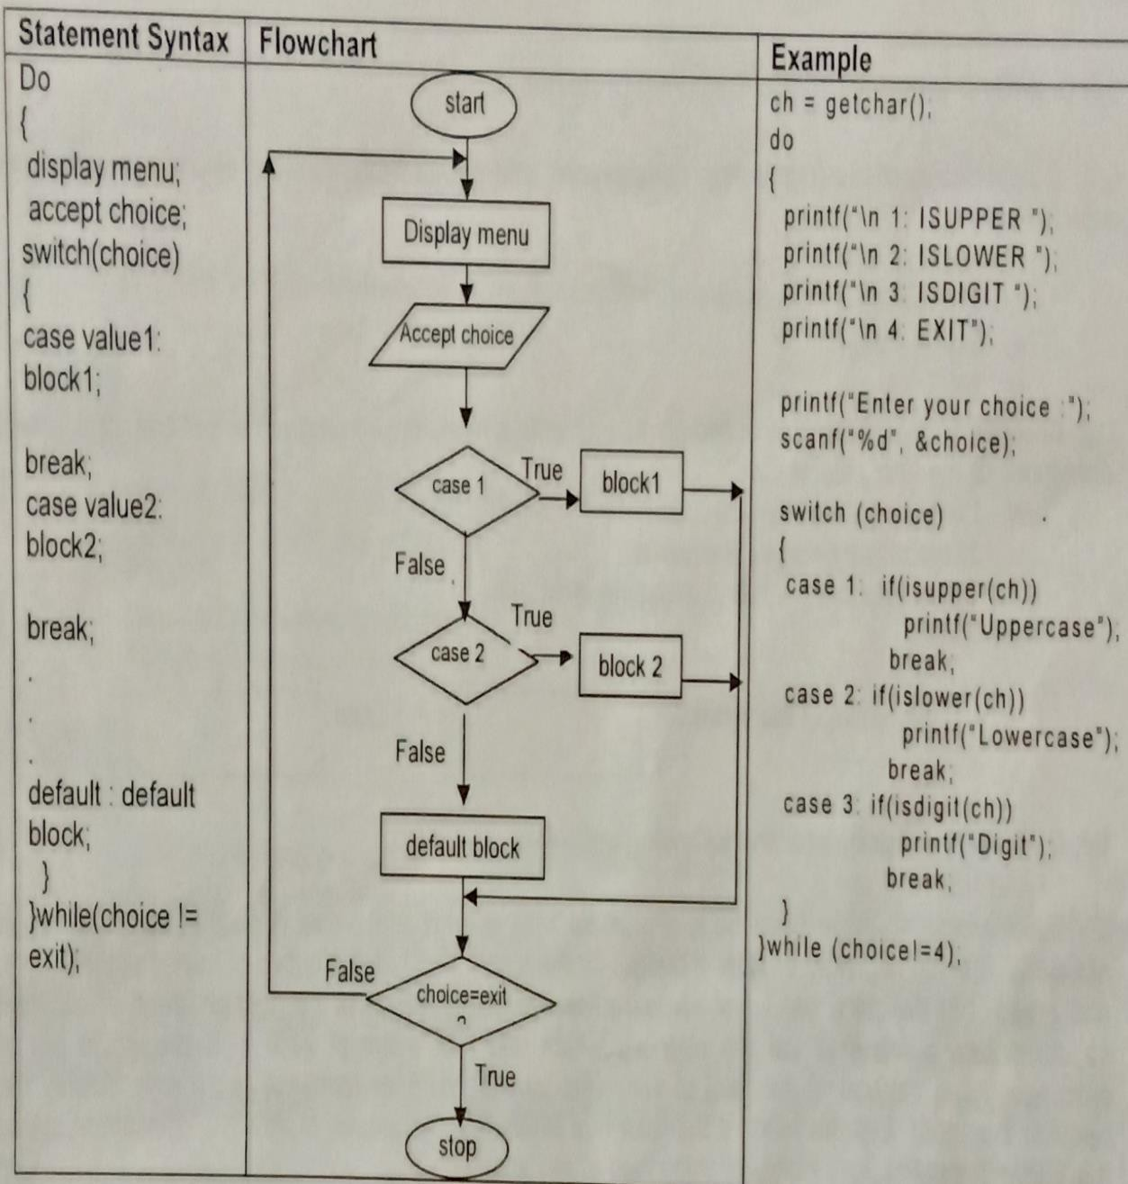

## Self-Activity

1. Write a menu driven program to perform the following operations on a character type variable.
   1. Check if it is an alphabet
   2. Check if it is a digit.
   3. Check if it is lowercase.
   4. Check if it is uppercase.
   5. Convert it to uppercase.
   6. Convert it to lowercase.

Refer to the sample code given above and use standard functions from ctype.h

Program:

## Set A . Write C programs for the following problems

1. Write a program, which accepts a character from the user and checks if it is an alphabet, digit or punctuation symbol. If it is an alphabet, check if it is uppercase or lowercase and then change the case.

Output:

Program:

1. Write a menu driven program to perform the following operations till the user selects Exit.

Accept appropriate data for each option. Use standard library functions from math.h

* 1. Power ii. Square Root iii. Floor iv. Ceiling v. Exit

Output:

Program:

## Set B. Write C programs for the following problems

1. Accept two fractions (numerator, denominator) and perform the following operations till the user selects Exit.
   1. Addition ii.Subtraction iii.Multiplication iv.EXIT

Output:

1. Accept x and y coordinates of two points and write a menu driven program to perform the Following operations till the user selects Exit.
2. Distance between points
3. Slope of line between the points.
4. Check whether they lie in the same quadrant.
5. EXIT

Program:

Output:

|  |  |  |
| --- | --- | --- |
| **Assignment Evaluation** |  | |
| 0: Not Done [ ] | 1: Incomplete [ ] | 2: Late Complete [ ] |
| 3: Needs Improvement [ ] | 4: Complete [ ] | 5: Well Done [ ] |

**Exercise 2: Date:**

## Objective:

To demonstrate writing C programs in modular way (use of user defined functions)

You should read following topics before starting this exercise

1. Declaring and Defining a function
2. Function call
3. Passing parameters to a function
4. Function returning a value

A function is a named sub-module of a program, which performs a specific, well-defined task. It can accept information from the calling function and return only 1 value. In C, every program has a function named main. main in turn calls other functions.

|  |  |  |  |
| --- | --- | --- | --- |
| **Sr.**  **No** | **Actions involving**  **functions** | **Syntax** | **Example** |
| 1. | Function  declaration | returntype function(type arg1, type arg2 … ); | void display();  int sum(int x, int y); |
| 2. | Function definition | returntype function(type arg1, type arg2 … )  {  /* statements*/  } | float calcarea (float r)  {  float area = Pi *r*r ; return area;  } |
| 3. | Function call | function(arguments);  variable = function(arguments); | display();  ans = calcarea(radius); |

## Sample code

The program given below calculates the area of a circle using a function and uses this function to calculate the area of a cylinder using another function.

main()

{

float areacircle (float r);

float areacylinder(float r, int h); float area, r;

printf(“\n Enter Radius: “); scanf(“%f”,&r); area=areacircle(r);

printf(“\n Area of circle =%6.2f”, area); printf(“\n Enter Height: “); scanf(“%d”,&h); area=areacylinder(r,h);

printf(“\n Area of cylinder =%6.2f”, area);

}

float areacircle (float r)

{

const float pi=3.142; return(pi * r*r );

}

float areacylinder (float r, int h)

{

return 2*areacircle(r)*h;

}

## Sample code

The function iswhitespace returns 1 if its character parameter is a space, tab or newline character. The program accepts characters till the user enters EOF and counts the number of white spaces.

main()

{

int iswhitespace (char ch); char ch;

int count=0;

printf(“\n Enter the characters. Type CTRL +Z to terminate: “);

while((ch=getchar())!=EOF) if(iswhitespace(ch)) count++;

printf(“\n The total number of white spaces =%d”, count);

}

int iswhitespace (char ch)

{

switch(ch)

{

case ‘ ‘:

case ‘\t’ :

case ‘\n’ : return 1; default : return 0;

}

}

## Self-Activity

* + - 1. Type the program given in sample code 1 above and execute the program. Add another function to calculate the volume of sphere and display it.
      2. Type the program given in sample code 2 above and execute the program. Modify the function such that it returns 1 if the character is a vowel. Also count the total number of vowels entered.

## Set A.Write C programs for the following problems

1. Write a function isEven, which accepts an integer as parameter and returns 1 if the number is even, and 0 otherwise. Use this function in main to accept n numbers and check if they are even or odd.

Program:

Output:

1. Write a function, which accepts a character and integer n as parameter and displays the next n characters.

Program:

Output:

## Set B . Write C programs for the following problems

1. Write a function isPrime, which accepts an integer as parameter and returns 1 if the number is prime and 0 otherwise. Use this function in main to display the first 10 prime numbers.

Program:

Output:

1. Write a function that accepts a character as parameter and returns 1 if it is an alphabet, 2 if it is a digit and 3 is it is a special symbol. In main, accept characters till the user enters EOF and use the function to count the total number of alphabets, digits and special symbols entered.

Program:

Output:

1. Write a function power, which calculates xy. Write another function, which calculates n! Using For loop. Use these functions to calculate the sum of first n terms of the Taylor series:

x3 x5

sin(x) = x -

3! 5!

+ + ……

Program:

Output:

|  |  |  |
| --- | --- | --- |
| **Assignment Evaluation** |  | |
| 0: Not Done [ ] | 1: Incomplete [ ] | 2: Late Complete [ ] |
| 3: Needs Improvement [ ] | 4: Complete [ ] | 5: Well Done [ ] |

**Exercise 3: Date:**

## Objective:

To demonstrate Recursion.

You should read the following topics before starting this exercise

1. Recursive definition
2. Declaring and defining a function
3. How to call a function
4. How to pass parameters to a function

Recursion is a process by which a function calls itself either directly or indirectly. The points to be remembered when recursive functions

1. Each time the function is called recursively it must be closer to the solution.
2. There must be some terminating condition, which will stop recursion.
3. Usually the function contains an if –else branching statement where one branch makes recursive call while other branch has non-recursive terminating condition

Expressions having recursive definitions can be easily converted into recursive functions

|  |  |  |  |
| --- | --- | --- | --- |
| **Sr. No** | **Recursive definition** | **Recursive Function** | **Sample program** |
| 1. | The recursive definition for factorial is given below:  n!= 1 if n = 0 or 1  = n * (n-1)! if n > 1 | long int factorial (int n)  {  If (n==0)||(n==1))  /* terminating condition */ return(1);  else  return(n* factorial(n-1));  /* recursive call */  } | #include <stdio.h> main()  {  int num;  /* function declaration */ long int factorial(int n);  printf(“\n enter the number:”); scanf(“%d”,&num);  printf(“\n The factorial of %d is  %ld”,num,factorial(num));  }  /* function code*/ |
| 2. | The recursive definition for nCr (no of combinations of r objects out of n objects) is as  follows nCn = 1  nC0 = 1  nCr = n-1Cr + nCr-1 | long int nCr( int n, int r)  {  if(n==r || r==0)  /* terminating condition */ return(1);  else  return( nCr(n-1,r)+nCr(n, r-1));  /* recursive call */  } | #include <stdio.h>  /* function code*/ main()  {  int n,r; ;  printf(“\n enter the total number of objects:”); scanf(“%d”,&n);  printf(“\n enter the number of objects to be  selected”); scanf(“%d”,&r);  printf(“\n The value %dC%d is  %ld”,n, r, nCr(n,r));  } |

## Self Activity

* 1. Write the sample program 1 given above and execute the program. Modify the program to Define a global integer variable count and increment it in factorial function. Add a printf statement in main function for variable count. Execute the program for different values and fill in the following table.

|  |  |  |  |
| --- | --- | --- | --- |
| **Sr. No.** | **num** | **factorial** | **count** |
| 1. | 0 |  |  |
| 2 | 1 |  |  |
| 3 | 5 |  |  |
| 4 |  |  |  |
| 5 |  |  |  |

* 1. Write the sample program 2 given above and execute the program for different values of n and

r. Modify the program to define a global integer variable count and increment it in nCr function.

Add a print statement in main function for variable count. Execute the program for different values and fill in the following table

|  |  |  |  |  |
| --- | --- | --- | --- | --- |
| **Sr. No.** | **n** | **r** | **nCr** | **count** |
| 1. | 5 | 0 |  |  |
| 2 | 5 | 5 |  |  |
| 3 | 5 | 2 |  |  |
| 4 | 5 |  |  |  |
| 5 |  |  |  |  |

## Set A . Write C programs for the following problems

* + 1. Write a recursive C function to calculate the sum of digits of a number. Use this function in main to accept a number and print sum of its digits.

Program:

Output:

* + 1. Write a recursive C function to calculate the GCD of two numbers. Use this function in main. The GCD is calculated as : gcd(a,b) = a if b = 0 = gcd (b, a mod b) otherwise

Program:

Output:

* + 1. Write a recursive C function to calculate xy. (Do not use standard library function)

Program:

Output:

## Set B . Write C programs for the following problems

Program:

1. Write a recursive function to calculate the nth Fibonacci number. Use this function in main to Display the first n Fibonacci numbers. The recursive definition of nth Fibonacci number is as follows:

fib(n) = 1 if n = 1 or 2

= fib(n-2) + fib(n-1) if n>2

Output:

Program:

1. Write a recursive function to calculate the sum of digits of a number till you get a single digit number.

Example: 961 -> 16 -> 5. (Note: Do not use a loop)

Output:

1. Write a recursive C function to print the digits of a number in reverse order. Use this function in main to accept a number and print the digits in reverse order separated by tab.

**Example: 3456 6 4 5 3**

Program:

(Hint: Recursiveprint(n) = print n if n is single digit number

= print n % 10 + tab + Recursiveprint( n/10)

Output:

|  |  |  |
| --- | --- | --- |
| **Assignment Evaluation** |  | |
| 0: Not Done [ ] | 1: Incomplete [ ] | 2: Late Complete [ ] |
| 3: Needs Improvement [ ] | 4: Complete [ ] | 5: Well Done [ ] |

# Activity Sheet 5 Date:

Arrays (1-D and 2-D) **Exercise 1 Objective**

To demonstrate use of 1-D arrays and functions.

## Reading

You should read the following topics before starting this exercise

1. What are arrays and how to declare an array?
2. How to enter data in to array and access the elements of an array.
3. How to initialize an array and how to check the bounds of an array?
4. How to pass an array to a function

An array is a collection of data items of the same data type referred to by a common name. Each element of the array is accessed by an index or subscript. Hence, it is also called a subscripted variable.

|  |  |  |
| --- | --- | --- |
| **Actions involving**  **arrays** | **syntax** | **Example** |
| Declaration of array | data-type array_name[size]; | int temperature[10];  float pressure[20]; |
| Initialization of array | data-type array_name[]={element1, element2, ……, element n};  data-type array_name[size]={element-1, element-2, ……, element-size}; | int marks[]={45,57,87,20,90};  marks[3] refers to the fourth element which equals 20 int count[3]={4,2,9};  count[2] is the last element 9 while 4 is count[0] |
| Accessing elements of an array | The array index begins from 0 (zero) To access an array element, we need to refer to it as array_name[index]. | Value = marks[3];  This refers to the 4th element in the array |
| Entering data into an array. |  | for(i=0; i<=9; i++)  scanf(“%d”, &marks[i]); |
| Printing the data from an array |  | for(i=0; i<=9; i++)  printf(“%d”, marks[i]); |
| Arrays and function | We can pass an array to a function using two methods.  Pass the array element by element Pass the entire array to the function | /* Passing the whole array*/ void modify(int a[5])  {  int i;  for(i=0; i<5 ; i++) a[i] = i;  } |

Sample program to find the largest element of an array

#include<stdio.h> int main()

{

int arr[20]; int n;

void accept(int a[20], int n); void display(int a[20], int n); int maximum(int a[20], int n);

printf(”How many numbers :”); scanf(“%d”, &n); accept(arr,n);

display(arr,n);

printf(“The maximum is :%d” , maximum(arr,n));

}

void accept(int a[20], int n)

{

int i;

for(i=0; i<n ; i++)

scanf(“%d”, &a[i]);

}

void display(int a[20], int n)

{

int i;

for(i=0; i<n ; i++)

printf(“%d\t”, a[i]);

}

int maximum(int a[20], int n)

{

int i, max = a[0]; for(i=1; i<n ; i++) if(a[i] > max)

max = a[i]; return max;

}

## Self Activity

1. Write a program to accept n numbers in an array and display the largest and smallest number. Using these values, calculate the range of elements in the array. Refer to the sample code given above and make appropriate modifications.
2. Write a program to accept n numbers in an array and calculate the average. Refer to the sample code given above and make appropriate modifications.

## Set A. Write programs to solve the following problems

1. Write a program to accept n numbers and display the array in the reverse order. Write separate functions to accept and display.

Program:

Output:

1. Write a function for Linear Search, which accepts an array of n elements and a key as parameters and returns the position of key in the array and -1 if the key is not found. Accept n numbers from the user, store them in an array. Accept the key to be searched and search it using this function. Display appropriate messages.

Program:

Output:

Program:

1. Write a function, which accepts an integer array and an integer as parameters and counts the occurrences of the number in the array.

Example: Input 1 5 2 1 6 3 8 2 9 15 1 30

Number : 1

Output: 1 occurs 3 times

Output:

Program:

1. Write a program to accept n numbers and store all prime numbers in an array called prime. Display this array.

Output:

## Set B. Write programs to solve the following problems

Program:

1. Write a function to sort an array of n integers using Bubble sort method. Accept n numbers from the user, store them in an array and sort them using this function. Display the sorted array.

Output:

Program:

1. Write a program to accept a decimal number and convert it to binary, octal and hexadecimal. Write separate functions.

Output:

Program:

1. Write a program to find the intersection of the two sets of integers. Store the intersection in another array.

Output:

1. Write a program to merge two sorted arrays into a third array such that the third array is also in the sorted order.

|  |  |  |  |  |  |
| --- | --- | --- | --- | --- | --- |
| a1 | 10 | 25 | 90 |  | |
| a2 | 9 | 16 | 22 | 26 | 100 |

a3 9 10 16 22 25 26 90 100

Program:

Output:

|  |  |  |
| --- | --- | --- |
| **Assignment Evaluation** |  | |
| 0: Not Done [ ] | 1: Incomplete [ ] | 2: Late Complete [ ] |
| 3: Needs Improvement [ ] | 4: Complete [ ] | 5: Well Done [ ] |

# Exercise 2

## Objective

To demonstrate use of 2-D arrays and functions.

You should read the following topics before starting this exercise

1. How to declare and initialize two-dimensional array
2. Accessing elements
3. Usage of two-dimensional arrays

|  |  |  |
| --- | --- | --- |
| **Actions involving**  **2-D arrays** | **syntax** | **Example** |
| Declaration of 2-D array | data-type array_name[size][size]; | int mat[10][10]; float sales[4][10]; |
| Initialization of 2- D array | data-type array_name[rows][cols]=  { {elements of row 0},{ elements of row  1},…..};  data-type array_name[][cols]={element1,  element2, ……, element size}; | int num[][2] = {12, 34, 23, 45, 56,45};  int num[3][2] = { {1,2}, {3,4}, {5,6}};  int num[3][2] = { 1,2,3,4, 5,6}; |
| Accessing elements of 2-D array | Accessing elements of 2-dimensional array - in general, the array element is referred as: array_name[index1][index2]  where index1 is the row location of and index2 is the column location of an element in the array. | int m[3][2];  m is declared as a two dimensional array (matrix) having 3 rows (numbered 0 to 2)  and 2 columns (numbered 0 to 1). The first element is m[0] [0] and the last is m [2][1]. value = m[1][1]; |
| Entering data into a 2-D array. |  | int mat[4][3];  for (i=0; i<4; i++)  /* outer loop for rows */ for (j=0;j<3; j++)  /* inner loop for columns */  scanf(“%d”, &mat[i][j]); |
| Printing the data from a 2-D array |  | for (i=0; i<4; i++)  /* outer loop for rows */  {  for (j=0;j<3; j++)  /* inner loop for columns */ printf(“%d\t” , mat[i][j]); printf(”\n”);  } |

Sample program to accept, display and print the sum of elements of each row of a matrix.

#include<stdio.h> int main()

{

int mat[10][10], m, n;

void display(int a[10][10], int m, int n); void accept(int a[10][10], int m, int n); void sumofrows(int a[10][10], int m, int n);

printf(“How many rows and columns? ”); scanf(“%d%d”,&m, &n);

printf(“Enter the matrix elements :”);

accept(mat, m, n);

printf(“\n The matrix is :\n”); display(mat, m, n); sumofrows(mat,m,n);

}

void accept(int a[10][10], int m, int n)

{

int i,j;

for (i=0; i<m; i++) /* outer loop for rows */ for (j=0;j<n; j++) /* inner loop for columns */ scanf(“%d”, &a[i][j]);

}

void display(int a[10][10], int m, int n)

{

int i,j;

printf(”\nThe elements of %d by %d matrix are\n”, m, n); for (i=0; i<m; i++) /* outer loop for rows */

{

for (j=0;j<n; j++) /* inner loop for columns */

printf(“%d\t” , a[i][j]); printf(”\n”);

}

}

void somofrows(int a[10][10], int m, int n)

{

int i,j, sum;

for (i=0; i<m; i++) /* outer loop for rows */

{

sum=0’

for (j=0;j<n; j++) /* inner loop for columns */ sum= sum+a[i][j];

printf(“Sum of elements of row %d = %d”, i, sum);

}

}

1. Write a program to accept, display and print the sum of elements of each row and sum of elements of each column of a matrix. Refer to sample code given above.

## Set A . Write C programs for the following problems.

* 1. Write a program to accept a matrix A of size m X n and store its transpose in matrix B. Display matrix B. Write separate functions.

Program:

Output:

* 1. Write a program to add and multiply two matrices. Write separate functions to accept, display, add and multiply the matrices. Perform necessary checks before adding and multiplying the matrices.

Program:

Output:

## Set B . Write C programs for the following problems.

1. Write a menu driven program to perform the following operations on a square matrix. Write separate functions for each option.
   1. Check if the matrix is symmetric.
   2. Display the trace of the matrix (sum of diagonal elements).
   3. Check if the matrix is an upper triangular matrix.
   4. Check if the matrix is a lower triangular matrix.
   5. Check if it is an identity matrix.

Program:

Output:

1. Write a program to accept an m X n matrix and display an m+1 X n+1 matrix such that the m+1th row contains the sum of all elements of corresponding row and the n+1th column contains the sum of elements of the corresponding column.

## Example:

|  |  |  |  |  |  |  |  |  |
| --- | --- | --- | --- | --- | --- | --- | --- | --- |
|  | | A |  |  |  | B |  | |
| 1 | 2 |  | 3 | 1 | 2 |  | 3 | 6 |
| 4 | 5 |  | 6 | 4 | 5 |  | 6 | 15 |
| 7 | 8 |  | 9 | 7 | 8 |  | 9 | 24 |
|  |  |  |  | 12 | 15 |  | 18 | 45 |

Program:

Output:

|  |  |  |
| --- | --- | --- |
| **Assignment Evaluation** |  | |
| 0: Not Done [ ] | 1: Incomplete [ ] | 2: Late Complete [ ] |
| 3: Needs Improvement [ ] | 4: Complete [ ] | 5: Well Done [ ] |